# Getting Started

This chapter will teach you how to start a excel 2010 application in simple steps. Assuming you have Microsoft Office 2010 installed in your PC, to start excel application, follow the following steps at your PC:

**Step (1):** Click **Start** button.

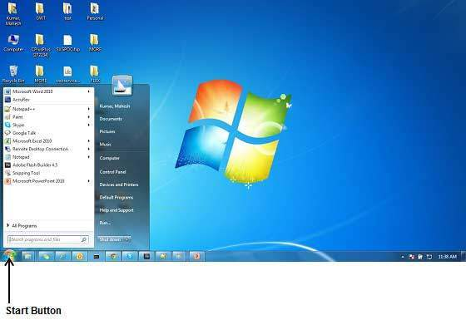

**Step (2):** Click **All Programs** option from the menu.



**Step (3):** Search for **Microsoft Office** from the sub menu and click it.

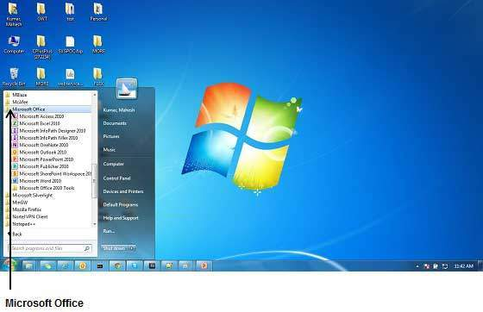

**Step (4):** Search for **Microsoft Excel 2010** from the submenu and click it.

This will launch Microsoft Excel 2010 application and you will see the following excel window.

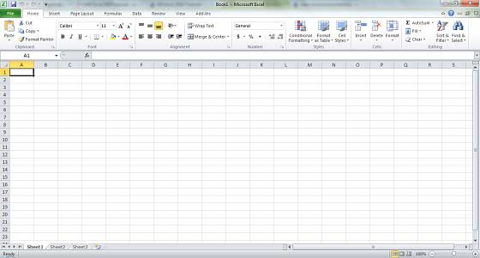

# Explore Window

Following is the basic window which you get when you start excel application. Let us understand various important parts of this window.

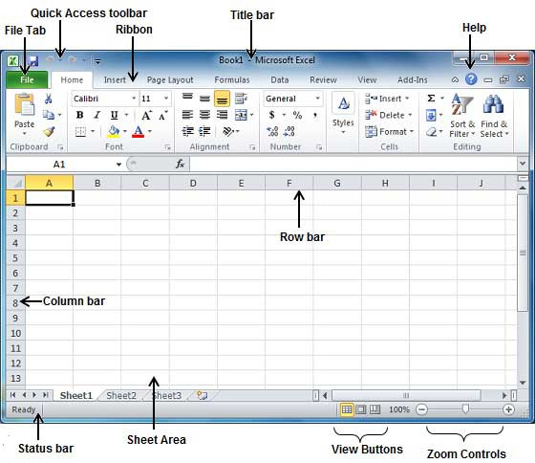

## File Tab:

The File tab replaces the Office button from Excel 2007. You can click it to check **Backstage view,** which is the place to come when you need to open or save files, create new sheets, print a sheet, and do other file-related operations.

## Quick Access Toolbar:

This you will find just above the **File tab** and its purpose is to provide a convenient resting place for the Excel most frequently used commands. You can customize this toolbar based on your comfort.

## Ribbon:

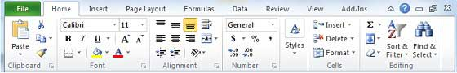

Ribbon contains commands organized in three components:

* **Tabs:** They appear across the top of the Ribbon and contain groups of related commands. Home, Insert, Page Layout are example of ribbon tabs.
* **Groups:** They organize related commands; each group name appears below the group on the Ribbon. For example group of commands related to fonts or group of commands related to alignment etc.
* **Commands:** Commands appear within each group as mentioned above.

## Title bar:

This lies in the middle and at the top or the window. Title bar shows the program and sheet titles.

## Help:

The **Help Icon** can be used to get excel related help anytime you like. This provides nice tutorial on various subjects related to excel.

## Zoom Control:

Zoom control lets you zoom in for a closer look at your text. The zoom control consists of a slider that you can slide left or right to zoom in or out, . and + buttons you can click to increase or decrease the zoom factor.

## View Buttons:

The group of three buttons located to the left of the Zoom control, near the bottom of the screen, lets you switch among excel's various sheet views.

* **Normal Layout view :** This displays page in normal view.
* **Page Layout view :**This displays pages exactly as they will appear when printed. This gives a full screen look of the document.
* **Page Break view :** This shows a preview of where pages will break when printed.

## Sheet Area:

The area where you enter data. The flashing vertical bar is called the **insertion point** and it represents the location where text will appear when you type.

## Row Bar

Rows are numbered from 1 onwards and keeps on increasing as you keep entering data. Maximum limit is 1,048,576 rows.

## Column Bar

Columns are numbered from A onwards and keeps on increasing as you keep entering data. After Z, it will start series of AA, AB and so on. Maximum limit is 16,384 columns.

## Status Bar:

This displays sheet information as well as the insertion point location. From left to right, this bar can contains the total number of pages and words in the document, language etc.

You can configure the status bar by right-clicking anywhere on it and by selecting or deselecting options from the provided list.

## Dialog Box Launcher:

This appears as very small arrow in the lower-right corner of many groups on the Ribbon. Clicking this button opens a dialog box or task pane that provides more options about the group.

# Back Stage View

The **Backstage view** has been introduced in Excel 2010 and acts as the central place for managing your sheets. The backstage view helps in creating new sheet, saving and opening sheets, printing and sharing sheets, and so on.

Getting to the Backstage View is easy: Just click the **File tab**, located in the upper-left corner of the Excel Ribbon. If you already do not have any opened sheet then you will see a window listing down all the recently opened sheets as follows:

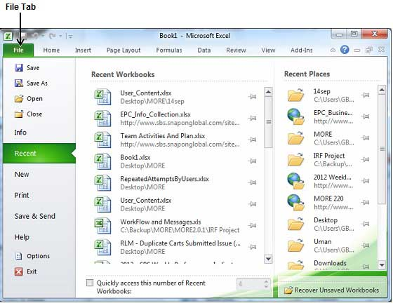

If you already have an opened sheet then it will display a window showing detail about the opened sheet as shown below. Backstage view shows three columns when you select most of the available options in the first column.

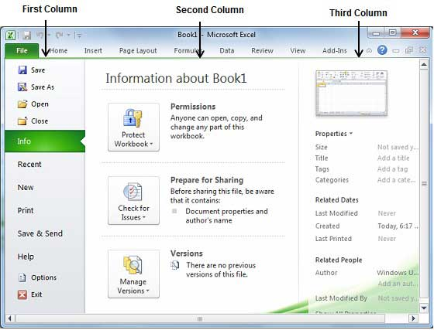

First column of the backstage view will have following options:

|  |  |
| --- | --- |
| Option | Description |
| Save | If an existing sheet is opened, it would be saved as is, otherwise it will display a dialogue box asking for sheet name. |
| Save As | A dialogue box will be displayed asking for sheet name and sheet type, by default it will save in sheet 2010 format with extension .xlsx |
| Open | This option will be used to open an existing excel sheet. |
| Close | This option will be used to close an opened . |
| Info | This option will display information about the opened sheet. |
| Recent | This option will list down all the recently opened sheets |
| New | This option will be used to open a new sheet. |
| Print | This option will be used to print an opened sheet. |
| Save & Send | This option will save an opened sheet and will display options to send the sheet using email etc. |
| Help | You can use this option to get required help about excel 2010. |
| Options | Use this option to set various option related to excel 2010. |
| Exit | Use this option to close the sheet and exit. |

## Sheet Information

When you click **Info** option available in the first column, it displays the following information in the second column of the backstage view:

* **Compatibility Mode:** If the sheet is not a native excel 2007/2010 sheet, a Convert button appears here, enabling you to easily update its format. Otherwise, this category does not appear.
* **Permissions:** You can use this option to protect your excel sheet. You can set a password so that nobody can open your sheet, or you can lock the sheet so that nobody can edit your sheet.
* **Prepare for Sharing:** This section highlights important information you should know about your sheet before you send it to others, such as a record of the edits you made as you developed the sheet.
* **Versions:** If the sheet has been saved several times, you may be able to access previous versions of it from this section.

## Sheet Properties

When you click **Info** option available in the first column, it displays various properties in the third column of the backstage view. These properties include sheet size, title, tags, categories etc.

You can also edit various properties. Just try to click on the property value and if property is editable then it will display a text box where you can add your text like title, tags, comments, Author.

## Exit Backstage View

It is simple to exit from Backstage View. Either click on **File tab** or press Esc button on the keyboard to go back in excel working mode.

# Entering Values

Let us see how easy is to enter text in a excel sheet. Hope you are aware that when you start a sheet, it displays a new sheet by default as shown below:

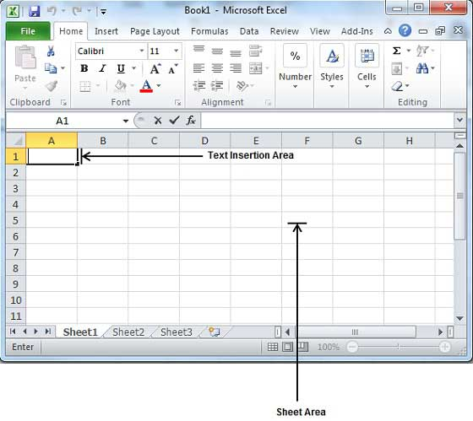

Sheet area is the area where you type your text. The flashing vertical bar is called the insertion point and it represents the location where text will appear when you type. When you click on a box then box becomes highlighted. When you double click the box flashing vertical bar will come and you can start entering data then.

So just keep your mouse cursor at the text insertion point and start typing whatever text you would like to type. I typed only two word "Hello Excel" as shown below. The text appears to the left of the insertion point as you type:

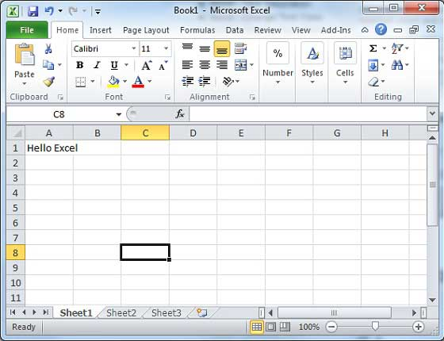

There are following three important points which would help you while typing:

* Press Tab to go to next column.
* Press Enter to go to next row.
* Press Alt + Enter to enter a new line in the same column.

# Move Around

Excel provides a number of ways to move around a sheet using the mouse and the keyboard.

First let us create some sample text before we proceed. Open a new excel sheet and type any data. We've shown a sample data in the screenshot.

|  |  |  |  |  |  |  |
| --- | --- | --- | --- | --- | --- | --- |
| **Order Date** | **Region** | **Rep** | **Item** | **Units** | **Unit Cost** | **Total** |
| 1/6/2010 | East | Jones | Pencil | 95 | 1.99 | 189.05 |
| 1/23/2010 | Central | Kivell | Binder | 50 | 19.99 | 999.5 |
| 2/9/2010 | Central | Jardine | Pencil | 36 | 4.99 | 179.64 |
| 2/26/2010 | Central | Gill | Pen | 27 | 19.99 | 539.73 |
| 3/15/2010 | West | Sorvino | Pencil | 56 | 2.99 | 167.44 |
| 4/1/2010 | East | Jones | Binder | 60 | 4.99 | 299.4 |
| 4/18/2010 | Central | Andrews | Pencil | 75 | 1.99 | 149.25 |
| 5/5/2010 | Central | Jardine | Pencil | 90 | 4.99 | 449.1 |
| 5/22/2010 | West | Thompson | Pencil | 32 | 1.99 | 63.68 |
| 6/8/2010 | East | Jones | Binder | 60 | 8.99 | 539.4 |
| 6/25/2010 | Central | Morgan | Pencil | 90 | 4.99 | 449.1 |
| 7/12/2010 | East | Howard | Binder | 29 | 1.99 | 57.71 |
| 7/29/2010 | East | Parent | Binder | 81 | 19.99 | 1,619.19 |
| 8/15/2010 | East | Jones | Pencil | 35 | 4.99 | 174.65 |

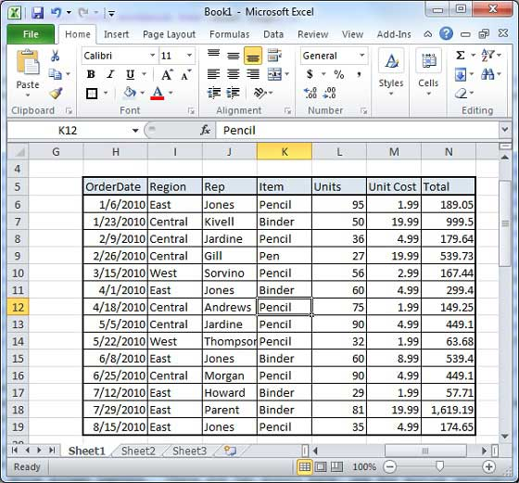

## Moving with Mouse

You can easily move the insertion point by clicking in your text anywhere on the screen. Sometime if sheet is big then you cannot see a place where you want to move. In such situation you would have to use the scroll bars, as shown in the following screen shot:

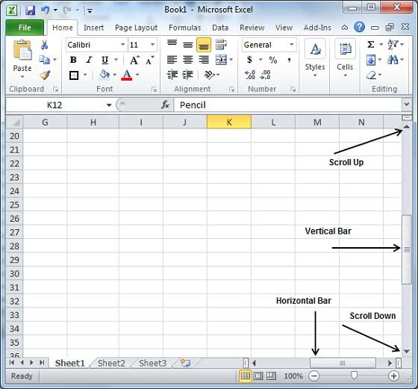

You can scroll your sheet by rolling your mouse wheel, which is equivalent to clicking the up-arrow or down-arrow buttons in the scroll bar.

## Moving with Scroll Bars

As shown in the above screen capture, there are two scroll bars: one for moving vertically within the sheet, and one for moving horizontally. Using the vertical scroll bar, you may:

* Move upward by one line by clicking the upward-pointing scroll arrow.
* Move downward by one line by clicking the downward-pointing scroll arrow.
* Move one next page, using next page button (footnote).
* Move one previous page, using previous page button (footnote).
* Use **Browse Object** button to move through the sheet, going from one chosen object to the next.

## Moving with Keyboard

The following keyboard commands, used for moving around your sheet, also move the insertion point:

|  |  |
| --- | --- |
| **Keystroke** | **Where the Insertion Point Moves** |
| Forward Arrow | Forward one box |
| Backword Arrow | Back one box |
| Upward Arrow | Up one box |
| Downard Arrow | Down one box |
| **PageUp** | To the previous screen |
| **PageDown** | To the next screen |
| **Home** | To the beginning of the current screen |
| **End** | To the end of the current screen |

You can move box by box or sheet by sheet.Now click in any box containing data in the sheet. You would have to hold down the Ctrl key while pressing an arrow key, which moves the insertion point as described here:

|  |  |
| --- | --- |
| **Key Combination** | **Where the Insertion Point Moves** |
| **Ctrl +** Forward Arrow | To the last box containing data of the current row |
| **Ctrl +** Backword Arrow | To the first box containing data of the current row |
| **Ctrl +** Upward Arrow | To the first box containing data of the current column |
| **Ctrl +** Downard Arrow | To the last box containing data of the current column |
| **Ctrl + PageUp** | To the sheet in the left of the current sheet. |
| **Ctrl + PageDown** | To the sheet in the right of the current sheet. |
| **Ctrl + Home** | To the beginning of the sheet |
| **Ctrl + End** | To the end of the sheet |

## Moving with Go To Command

Press **F5** key to use Go To command, which will display a dialogue box where you will have various options to reach to a particular box.

Normally we use row and column number, for example K5 and finally press **Go To** button.

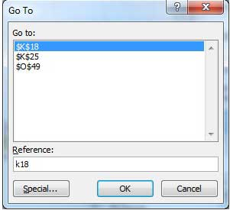

# Save Workbook

## Saving New Sheet

Once you are done with typing in your new excel sheet, it is time to save your sheet/workbook to avoid losing work you have done on an Excel sheet. Following are the steps to save an edited excel sheet:

**Step (1) :** Click the **File tab** and select **Save As** option.

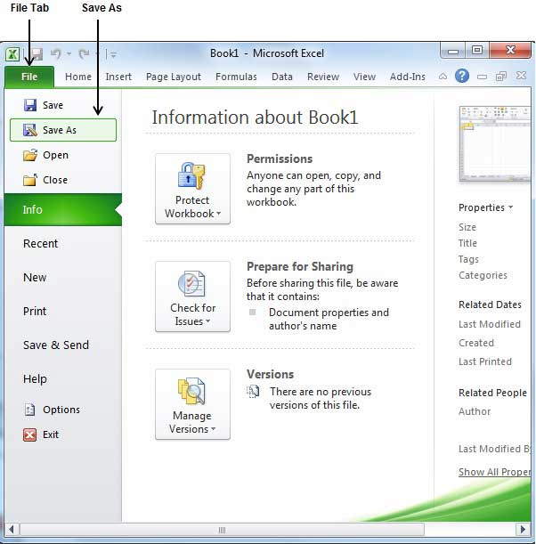

**Step (2) :** Select a folder where you would like to save the sheet, Enter file name which you want to give to your sheet and Select a Save as type, by default it is **.xlsx** format.

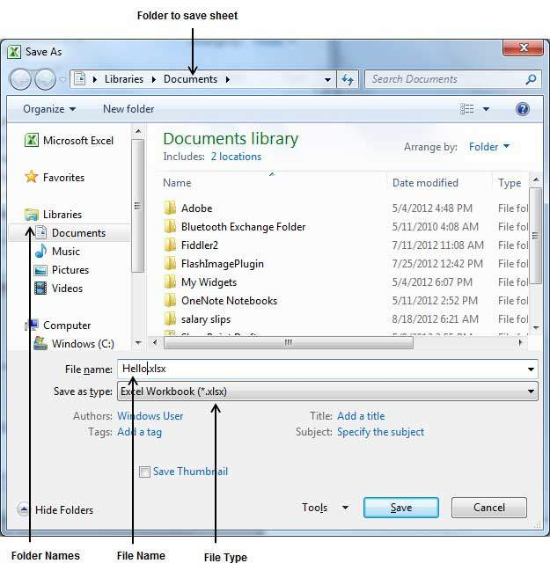

**Step (3) :** Finally, click on **Save** button and your sheet will be saved with the entered name in the selected folder.

## Saving New Changes

There may be a situation when you open an existing sheet and edit it partially or completely, or even you would like to save the changes in between editing of the sheet. If you want to save this sheet with the same name then you can use either of the following simple options:

* Just press **Ctrl + S** keys to save the changes.
* Optionally you can click on the floppy icon available at the top left corner and just above the **File tab**. This option will also save the changes.
* You can also use third method to save the changes, which is **Save** option available just above the **Save As** option as shown in the above screen capture.

If your sheet is new and it was never saved so far, then with either of the three options, word would display you a dialogue box to let you select a folder, and enter sheet name as explained in case of saving new sheet.

# Create Worksheet

## Creating New Worksheet

Three new, blank sheets always open when you start Microsoft Excel. But suppose that you want start another new worksheet while you are working on another worksheet, or you closed already opened worksheet and want to start a new worksheet. Here are the steps to create a new worksheet:

**Step (1) :** Right Click the **Sheet Name** and select **Insert** option.

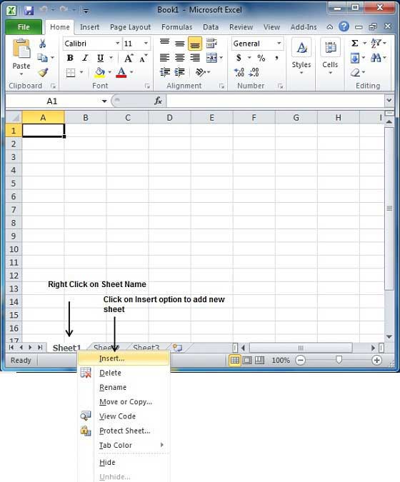

**Step (2) :** Now you'll see the Insert dialog with select **Worksheet** option as selected from the general tab. Click **Ok** button

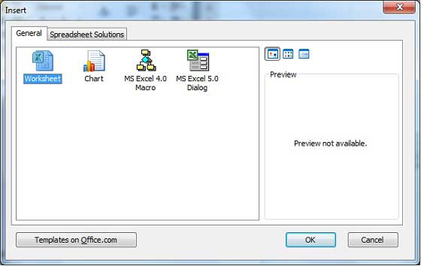

Now you should have your blank sheet as shown below ready to start typing your text.

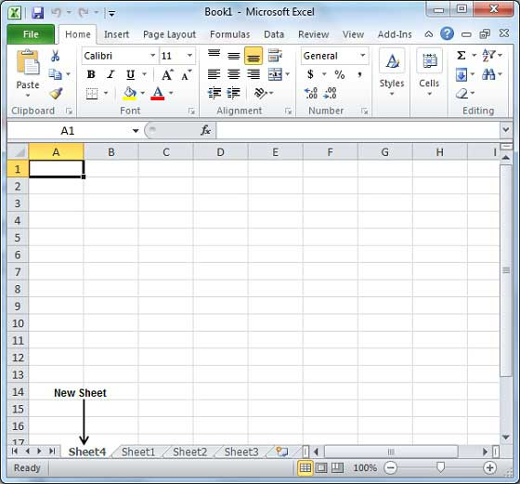

You can use a short cut to create a blank sheet anytime. Try using **Shift+F11** keys and you will see a new blank sheet similar to above sheet is opened.

# Copy Worksheet

## Copy Worksheet

First let us create some sample text before we proceed. Open a new excel sheet and type any data. We've shown a sample data in the screenshot.

|  |  |  |  |  |  |  |
| --- | --- | --- | --- | --- | --- | --- |
| **OrderDate** | **Region** | **Rep** | **Item** | **Units** | **Unit Cost** | **Total** |
| 1/6/2010 | East | Jones | Pencil | 95 | 1.99 | 189.05 |
| 1/23/2010 | Central | Kivell | Binder | 50 | 19.99 | 999.5 |
| 2/9/2010 | Central | Jardine | Pencil | 36 | 4.99 | 179.64 |
| 2/26/2010 | Central | Gill | Pen | 27 | 19.99 | 539.73 |
| 3/15/2010 | West | Sorvino | Pencil | 56 | 2.99 | 167.44 |
| 4/1/2010 | East | Jones | Binder | 60 | 4.99 | 299.4 |
| 4/18/2010 | Central | Andrews | Pencil | 75 | 1.99 | 149.25 |
| 5/5/2010 | Central | Jardine | Pencil | 90 | 4.99 | 449.1 |
| 5/22/2010 | West | Thompson | Pencil | 32 | 1.99 | 63.68 |
| 6/8/2010 | East | Jones | Binder | 60 | 8.99 | 539.4 |
| 6/25/2010 | Central | Morgan | Pencil | 90 | 4.99 | 449.1 |
| 7/12/2010 | East | Howard | Binder | 29 | 1.99 | 57.71 |
| 7/29/2010 | East | Parent | Binder | 81 | 19.99 | 1,619.19 |
| 8/15/2010 | East | Jones | Pencil | 35 | 4.99 | 174.65 |



Here are the steps to copy an entire worksheet

**Step (1) :** Right Click the **Sheet Name** and select **Move or Copy** option.

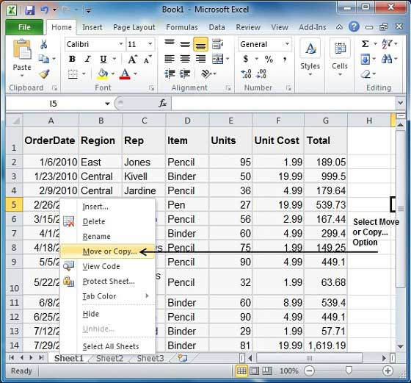

**Step (2) :** Now you'll see the Move or Copy dialog with select **Worksheet** option as selected from the general tab. Click **Ok** button

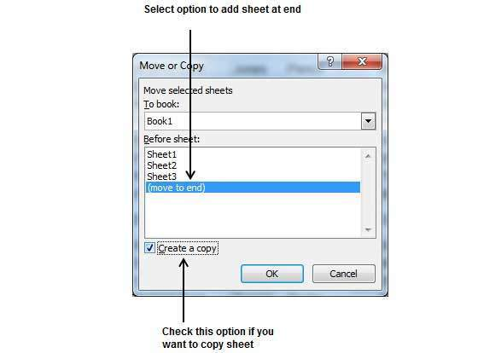

Select **Create a Copy** Checkbox to create a copy of current sheet and Before sheet option as **(move to end)** so that new sheet gets created at end.

Press **Ok** Button

Now you should have your copied sheet as shown below.

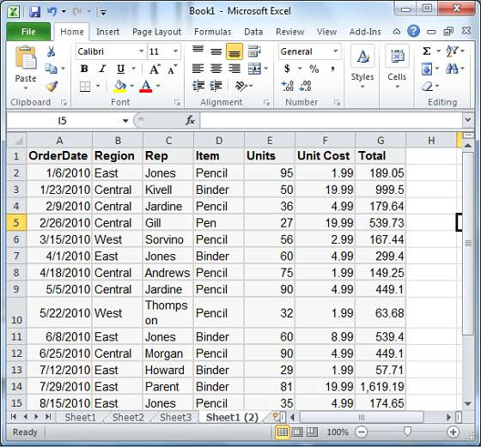

You can rename the sheet by double clicking on it.On double click, name become editable. Enter any name say Sheet5 and press Tab or Enter Key.

# Hiding Worksheet

## Hiding Worksheet

Here is the step to hide a worksheet

**Step (1)** Right Click the **Sheet Name** and select **Hide** option. Sheet will get hidden.

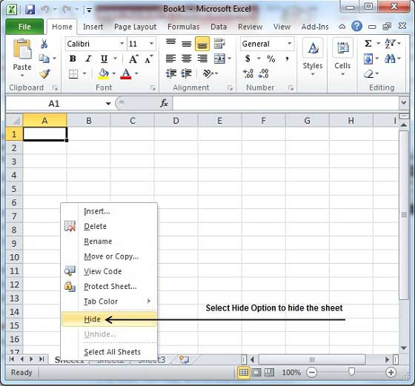

## Unhiding Worksheet

Here are the steps to unhide a worksheet

**Step (1)** Right Click on any **Sheet Name** and select **Unhide...** option.

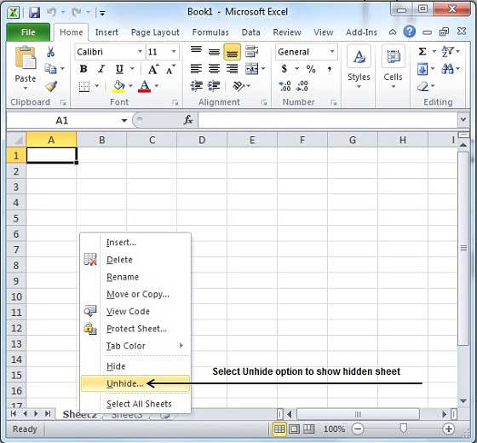

**Step (2)** Select **Sheet Name** to unhide in **Unhide** dialog to unhide the sheet.

Press **Ok** Button

Now you will have your hidden sheet back.

# Delete Worksheet

## Delete Worksheet

Here is the step to delete a worksheet

**Step (1)** Right Click the **Sheet Name** and select **Delete** option.

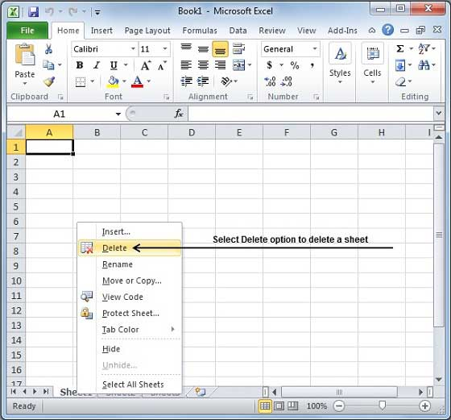

Sheet will get deleted if it is empty otherwise you'll see a confirmation message.

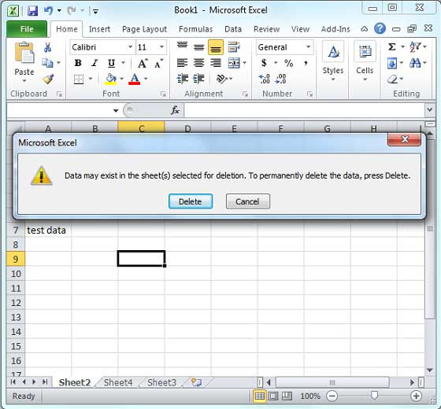

**Step (2)** Press **Delete** Button

Now your worksheet will get deleted.

## Close Workbook

Here are the steps to close a workbook

**Step (1)** Click the **Close Button** as shown below.

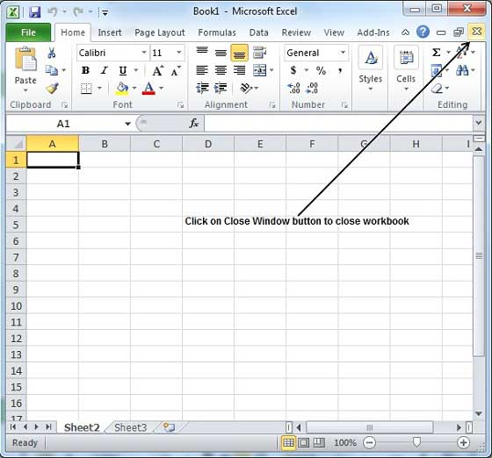

You'll see a confirmation message to save the workbook.

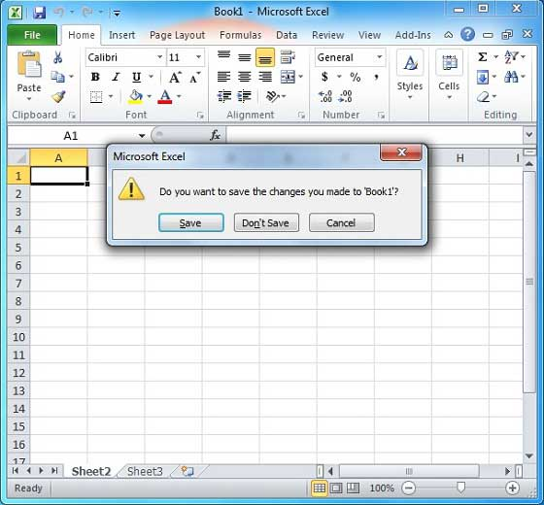

**Step (2)** Press **Save** Button to save the workbook as we did in [MS Excel - Save Workbook](http://www.tutorialspoint.com/excel/excel_save_workbook.htm) chapter.

Now your worksheet will get closed.

# Open Workbook

**Open Workbook**

Let us see how to open workbook from excel

**Step (1)** Click the **File Menu** as shown below. You can see **open option** in **File Menu.** There are two more columns Recent workbooks and Recent places where you can see recently opened workbooks and recent places from where workbooks are opened.

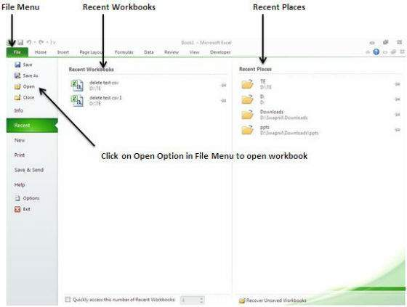

**Step (2)** Clicking the **Open Option** will open the browse dialog as shown below. Browse the directory and find file you need to open.

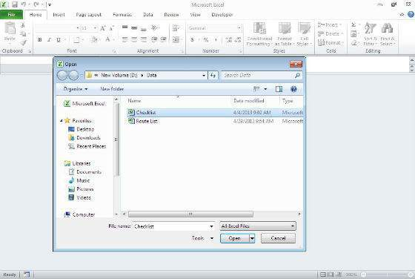

**Step (3)** Once you select the workbook your workbook will be opened as below:

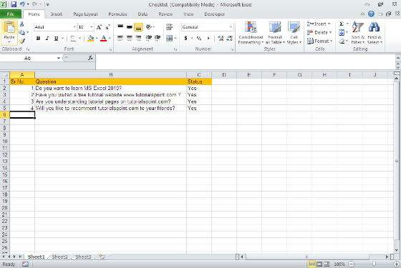

# Context Help

MS Excel provides context sensitive help on mouse over. To see context sensitive help for Particular Menu option hover the mouse over the option for some time. Then you can see context sensitive Help as shown below

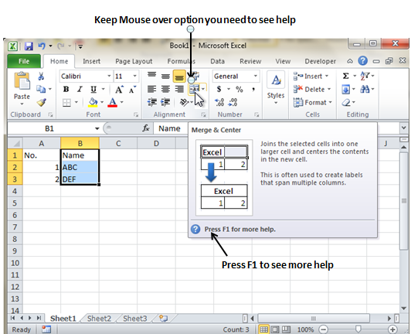

## Getting More Help

For getting more help with MS Excel from Microsoft you can press **F1** or by **File -> Help -> Support -> Microsoft office Help**

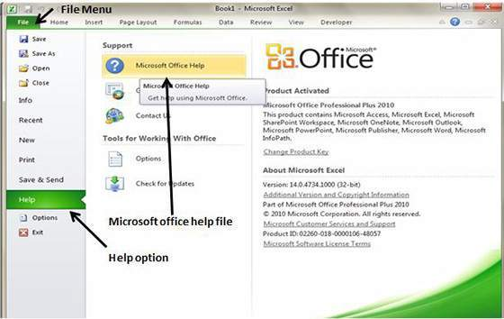

# Insert Data

In **MS Excel** there are **1048576*16384** cells.MS Excel cell can have **Text, Numeric value or formulas.** MS Excel cell can have maximum of 32000 characters.

## Inserting Data

For **inserting data** in **MS Excel** just activate the cell type text or number and press enter or Navigation key.

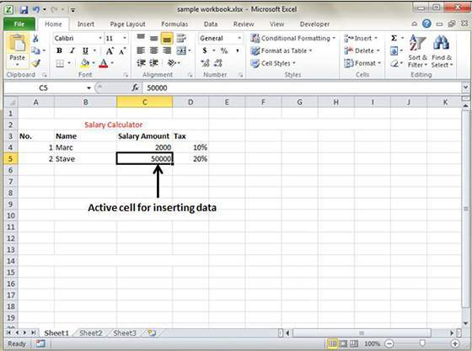

## Inserting Formula

For inserting formula in MS Excel go to formula bar, enter the formula and then press enter or navigation key. See the screen-shot below to understand it.

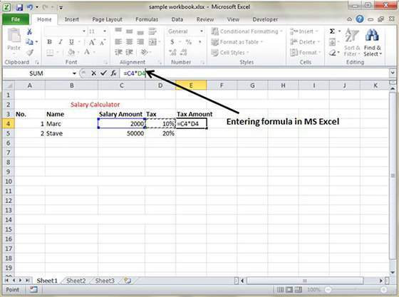

## Modifying Cell Content

For modifying the cell content just activate the cell, enter a new value and then press enter or navigation key to see changes. See the screen-shot below to understand it.

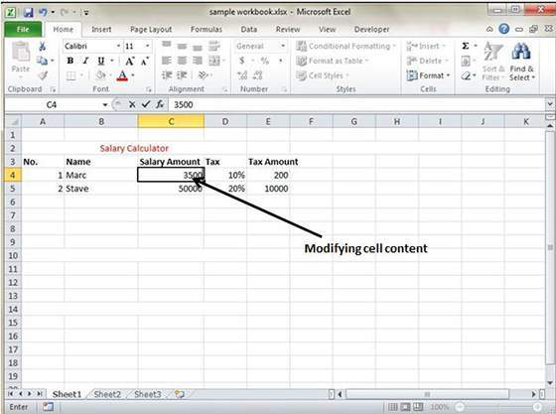

# Select Data

**MS Excel** provides various ways of selecting data in the sheet. Let us see those ways.

## Select with Mouse

Drag the mouse over the data you want to select. It will select those cells as shown below.

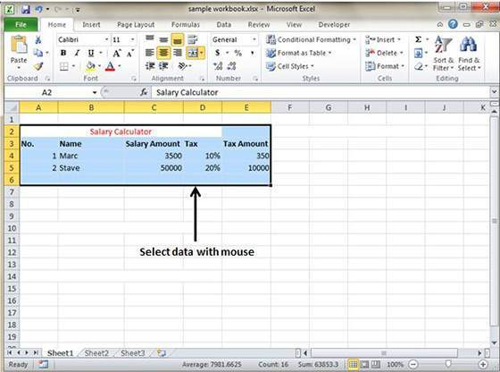

## Select with Special

If you want to select specific region, select any cell in that region. Pressing **F5** will show below dialogue.

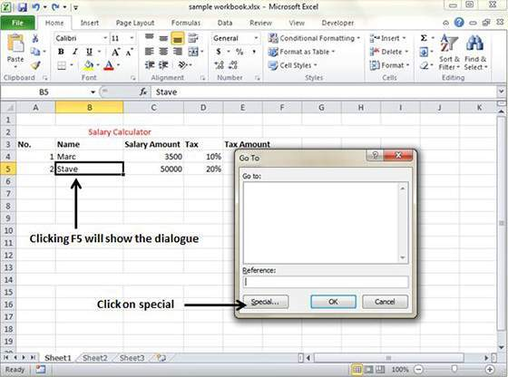

Click on **Special button** to see below dialogue. Select **current region** from the radio buttons. Click on **ok** to see current region selected.

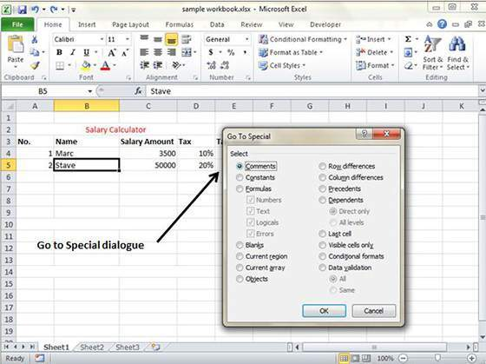

AS you can see in below screen the data is selected for current region.

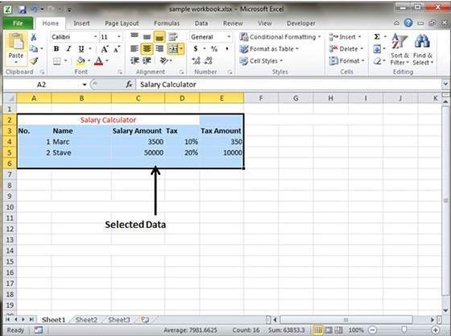

**MS Excel** provides various ways of deleting data in the sheet. Let us see those ways.

## Delete with Mouse

Select the data you want to delete. **Right Click** on the sheet. Select the **delete option**, it will delete the data.

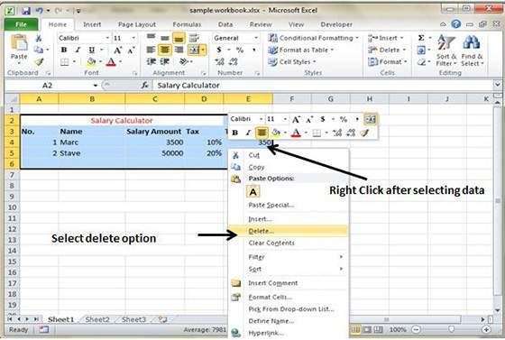

## Delete with Delete Key

Select the data you want to delete. Press on the **Delete Button** from the keyboard, it will delete the data.

## Selective Delete for rows

Select the rows which you want to delete with **Mouse click + Control Key.** Then right click it will show various options. Select the **Delete option** to delete the selected rows.

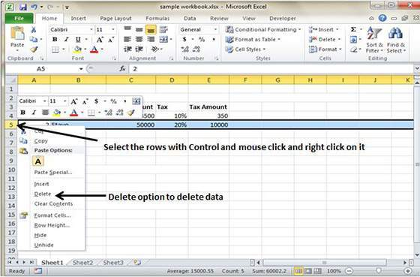

# Move Data

Let us see how we can **Move Data** with **MS Excel.** **Step(1)** Select the data you want to Move.**Right Click** on the it. Select the **cut option.**

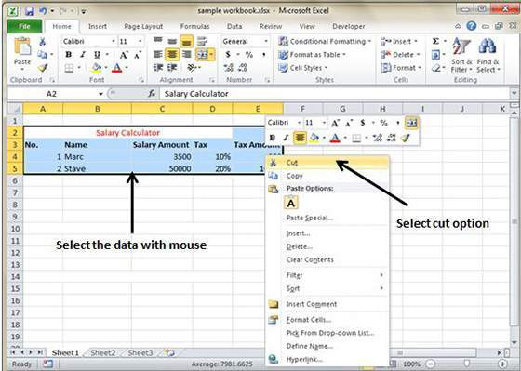

**Step(2) Select the first cell** where you want to move the data. Right click on it and **paste the data.** You can see the data is moved now.

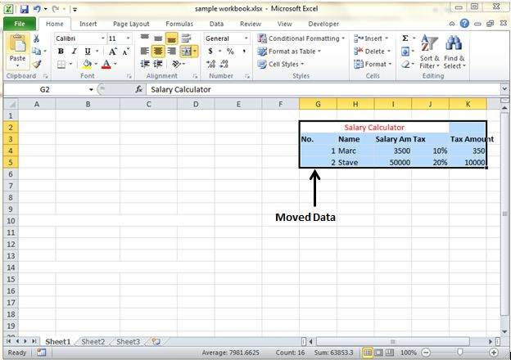

# Rows & Columns

## Row and Column Basics

**MS Excel** is in tabular format consisting of rows and columns.

* Row runs horizontally while Column runs vertically.
* Each row is identified by row number which runs vertically at the left of the sheet.
* Each column is identified by column header which runs horizontally at the top of sheet

For **MS Excel** 2010 Row numbers ranges from **1 to 104857** in total **1048576** rows and Columns ranges from **A to XFD** in total **16384** columns

## Navigation with rows and columns

Let us see how to move to last row or last column.

* You can go to last row by clicking **Control + Down Navigation arrow.**
* You can go to last column by clicking **Control + Right Navigation arrow.**

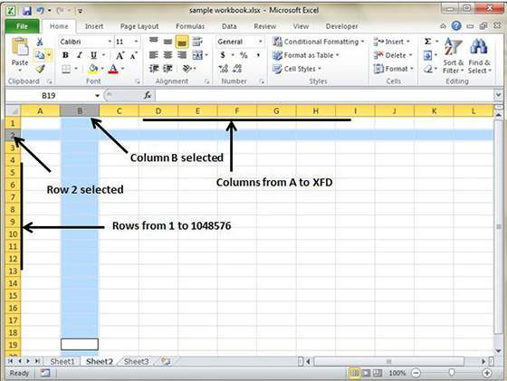

## Cell Introduction

The intersection of rows and columns is called **cell**.

Cell is identified with **Combination of column header and row number.**

For example: A1, A2

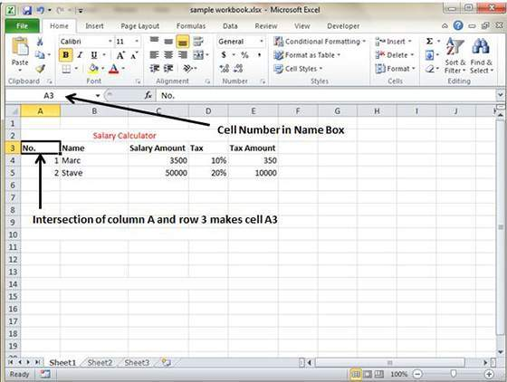

# Copy & Paste

**MS Excel** is in provides **copy paste** option in different ways.The simplest method of copy paste is as below.

## Copy Paste

* To do copy paste just select the cells you want to copy. Choose **copy option** after right click or press **Control + C.**
* Select the cell where you need to paste this copied content. Right click and select paste option or press **Control + V.**

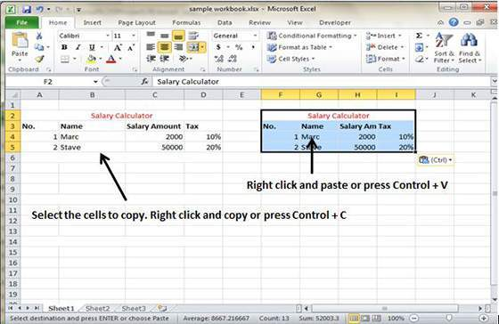

In this case **MS Excel** will copy everything values, formula, Formats, Comments and validation. MS Excel will overwrite the content with paste. If you want to undo this press **Control + Z**

## Copy Paste using Office Clipboard

When you copy data in MS Excel it puts the copied content in Windows and Office Clipboard. You can view clipboard content by **Home -> Clipboard.** View the clipboard content. Select cell where you need to paste. Click on paste to paste the content.

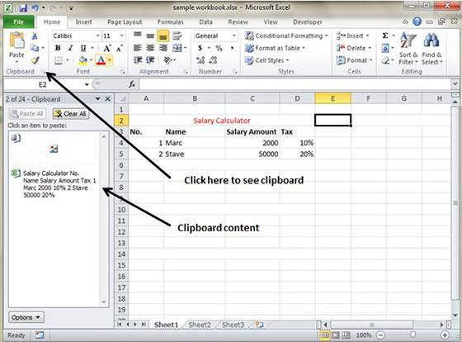

## Copy Paste in Special way

You may not want to copy everything in some cases for example you want to copy only Values or you want to copy only formatting of cells. Select the paste special option as below.



Below are the various options available in paste special.

* **All:** Pastes the cell’s contents, formats, and data validation from the Windows Clipboard.
* **Formulas:** Pastes formulas, but not formatting.
* **Values:** Paste only values not the formulas.
* **Formats:** Pastes only the formatting of the source range.
* **Comments:** Pastes the comments with the respective cells.
* **Validation:** Paste validation applied in the cells.
* **All using source theme:** Pastes formulas, and all formatting.
* **All except borders:** Pastes everything except borders that appear in the source range.
* **Column Width:** Pastes formulas, and also duplicates the column width of the copied cells.
* **Formulas & Number Formats:** Pastes formulas and number formatting only.
* **Values & Number Formats :** Pastes the results of formulas, plus the number
* **Merge Conditional Formatting:** This icon is displayed only when the copied cells contain conditional formatting. When clicked, it merges the copied conditional formatting with any conditional formatting in the destination range.
* **Transpose:** Changes the orientation of the copied range. Rows become columns, and columns become rows. Any formulas in the copied range are adjusted so that they work properly when transposed.

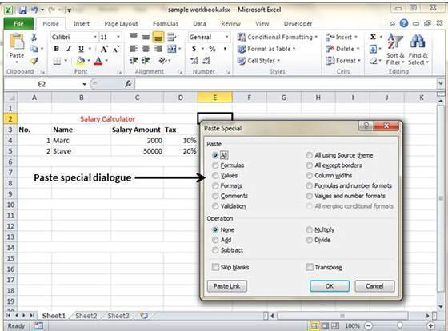

# Find & Replace

**MS Excel** Provides **Find & Replace** option for finding text within the sheet.

## Find and Replace Dialogue

Let us see how to access Find & Replace Dialogue.

To access the Find & Replace, Choose **Home -> Find & Select -> Find** or press **Control + F Key**.See below image.

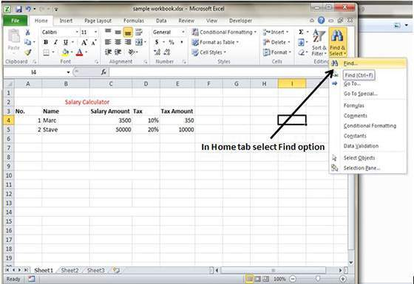

You can see the **Find and Replace dialogue** as below.

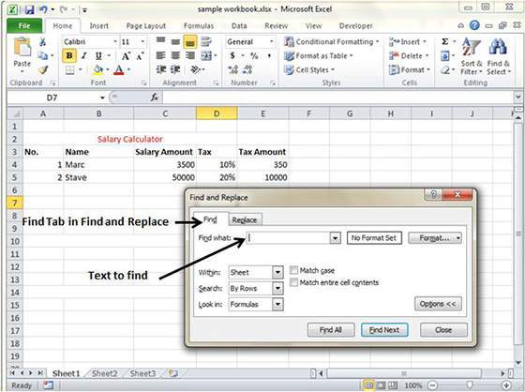

You can replace the found text with the new text with **Replace tab**

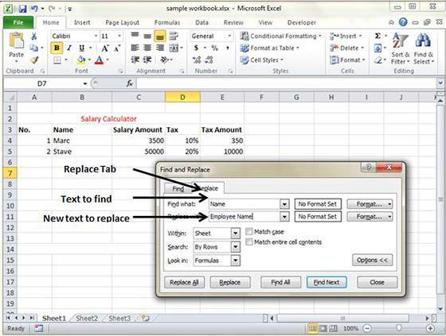

## Exploring options

Now Let us see various options available under the Find dialogue.

* **Within :** Specifying the search should be in Sheet or workbook.
* **Search By :** Specifying the internal search method by rows or by columns.
* **Look In :** If you want to find text in formula as well then select this option.
* **Match Case :** If you want to match the case like lower case or upper case of words then check this options
* **Match Entire Cell Content :** If you want to exact match of the word with cell then check this option.

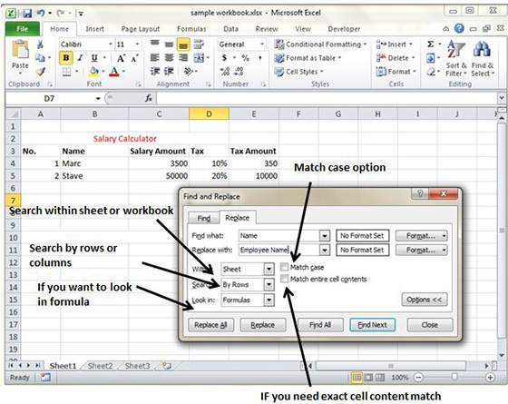

# Spell Check

**MS Excel** Provides feature of Word Processing program **Spelling check.** We can get rid of the spelling mistakes with the help of spelling check feature.

## Spell Check basis

Let us see how to access spell check.

* To access the spell checker, Choose **Review ➪ Spelling** or press **F7**.
* To check the spelling in just a particular range, **select the range** before you activate the spell checker.
* If the spell checker finds any words it does not recognize as correct, it displays the **Spelling dialogue** with suggested options.

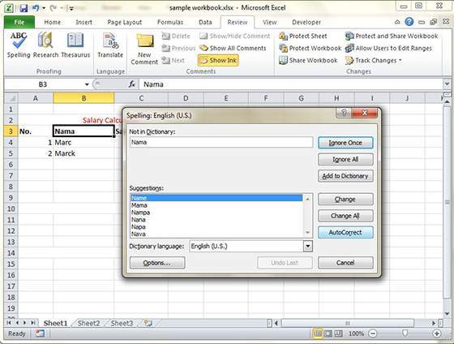

## Exploring options

Let us see various options available in **spell check** dialogue.

* **Ignore Once :** Ignore the word and continues the spell check.
* **Ignore All :** Ignore the word and all subsequent occurrences of it.
* **Add to Dictionary :** Add the word to the dictionary.
* **Change :** Change the word to the selected word in the Suggestions list.
* **Change All :** Change the word to the selected word in the Suggestions list and change all subsequent occurrences of it without asking.
* **AutoCorrect :** Add the misspelled word and its correct spelling (which you select from the list) to the AutoCorrect list.

# Zoom In/Out

## Zoom Slider

By default everything on screen is displayed at 100% in MS Excel. You can change the zoom percentage from 10% (tiny) to 400% (huge). Zooming doesn’t change the font size, so it has no effect on printed output.

You can view the zoom slider at the right bottom of the workbook as below.

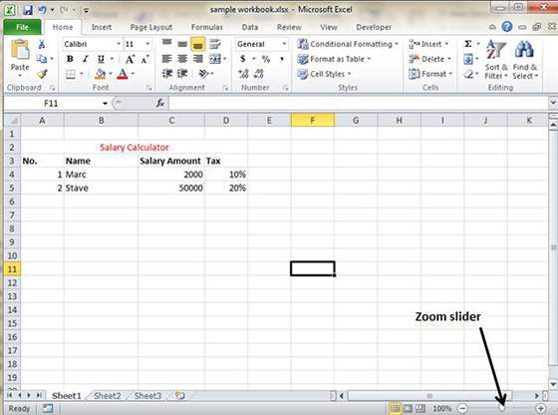

## Zoom In

You can zoom In the workbook by moving slider to right. It will change the only view of the workbook. You can have maximum of 400% zoom in. See below screen-shot.

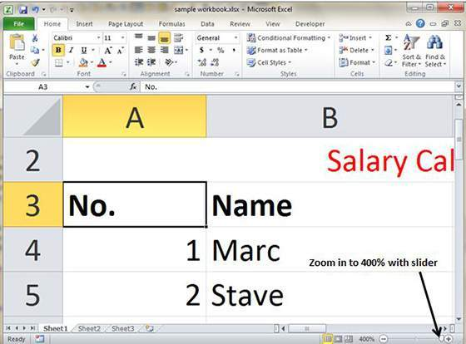

## Zoom Out

You can zoom out the workbook by moving slider to left. It will change the only view of the workbook. You can have maximum of 10% zoom in. See below screen-shot.

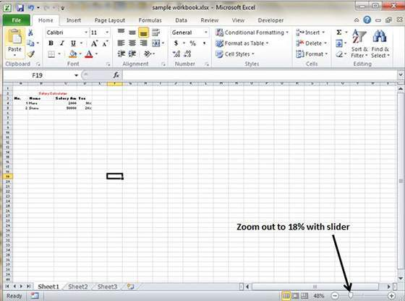

# Special Symbols

If you want to insert some symbols or special characters that are not found on the keyboard in that case you need to use Symbols option

## Using Symbols

Go to **Insert » Symbols » Symbol** to view available symbols. You can see many symbols available there like Pi, alpha, beta, etc.

Select the symbol you want to add and click insert to use the symbol

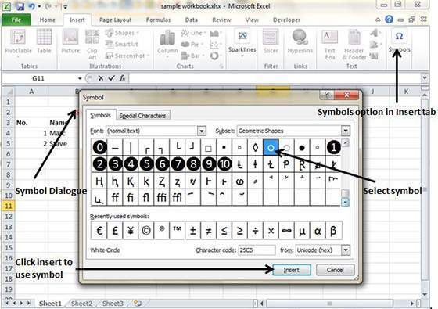

## Using Special characters

Go to **Insert » Symbols » Special Characters** to view available special characters. You can see many special characters available there like Copyright, Registered etc

Select the special character you want to add and click insert to use the special character

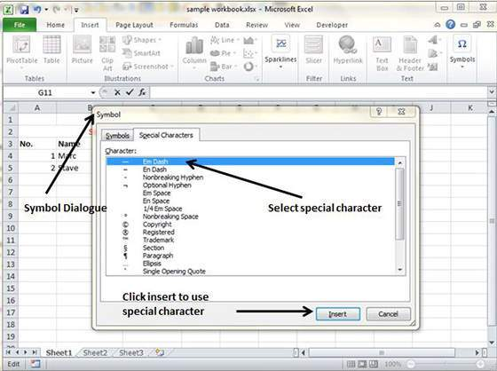

# Insert Comments

## Adding comment to cell

Adding comment to cell helps in understanding the purpose of cell, what input it should have, etc. It helps in proper documentation

To add comment to cell select the cell and perform any of the action below

* Choose Review » Comments » New Comment
* Right-click the cell and choose Insert Comment from available options.
* Press Shift+F2

Initially comment consist of Computer's user name. You have to modify it with text for the cell comment

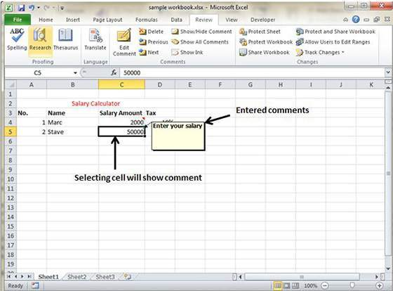

## Modifying comment

You can modify the comment you entered before as below.

* Select the cell on which comment appears.
* Right-click the cell and choose Edit Comment from available options.
* Modify the comment

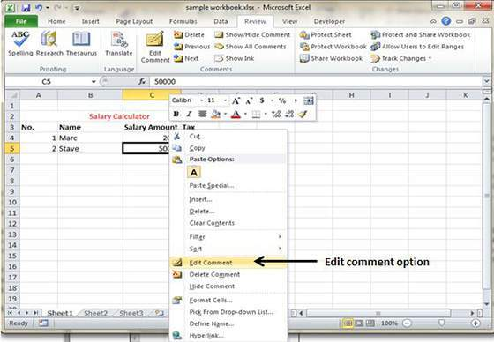

## Formatting comment

You can do several formatting of comments.For formatting comment **Right click on cell » Edit comment » Select comment » Right click on it » Format comment** With formatting of comment you can change color, font, size,etc of the comment.

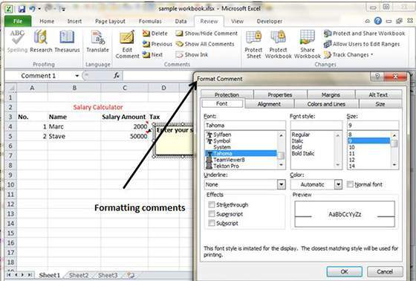

# Add Text Box

## Text Boxes

Text boxes are special graphic objects that combine text with a rectangular graphic object. Text boxes and cell comment are similar in that they display text in rectangular box but text boxes are always visible while cell comment becomes visible after selecting cell.

## Adding text boxes

To add text box perform below actions.

* Choose Insert » Text Box » choose text box or draw it

Initially comment consist of Computer's user name. You have to modify it with text for the cell comment

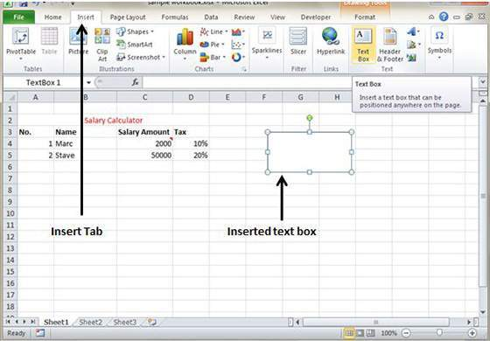

## Formatting text box

After you added text box, you can format text box by changing the font, font size, font style, and alignment, etc. Let us see some of the important options there.

* **Fill :** Specifies filling of text box like No fill, solid fill. Also specifying transparency of text box fill.
* **Line Colour :** Specifies the line colour and transparency of the line.
* **Line Style :** Specifies line style and width.
* **Size :** Specifies the size of the text box.
* **Properties :** Specifies some properties of text box.
* **Text Box :** Specifies text box layout , Auto-fit option and internal margins.

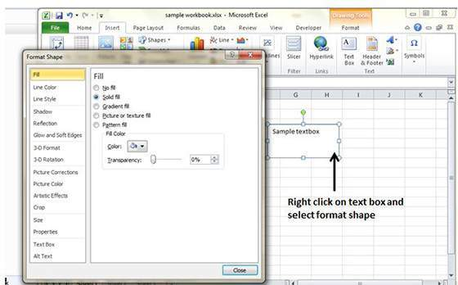

# Undo Changes

You can reverse almost every action in Excel by using the Undo command. We can undo changes in 2ways.

* From the Quick access tool-bar » Click Undo
* Press Control + Z

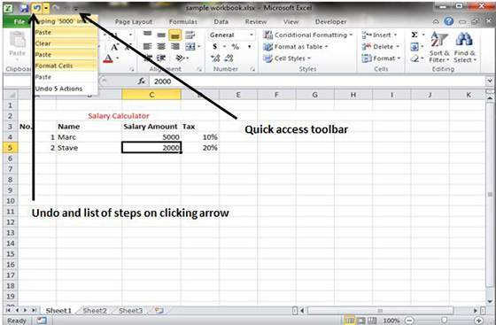

You can reverse the effects of the past 100 actions that you performed by executing Undo more than once. If you click the arrow on the right side of the Undo button, you see a list of the actions that you can reverse. Click an item in that list to undo that action and all the subsequent actions you performed.

## Redo Changes

You can again reverse back the action done with undo in Excel by using the Redo command. We can redo changes in 2ways.

* From the Quick access tool-bar » Click Redo
* Press Control + Y

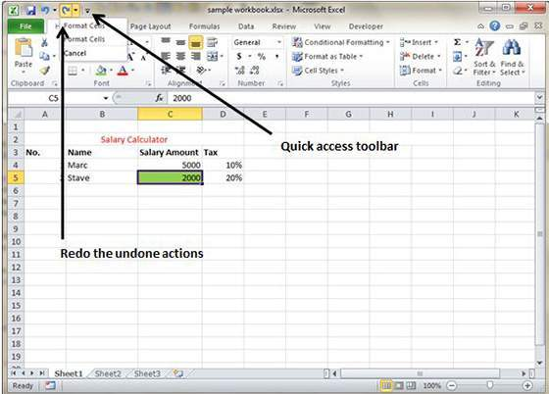

# Setting Cell Type

## Formatting Cell

MS Excel Cell can hold different types of data like Numbers, Currency, Dates, etc. You can set the cell type in various ways as below:

* **Right Click on the cell » Format cells » Number**
* Click on the Ribbon from the ribbon

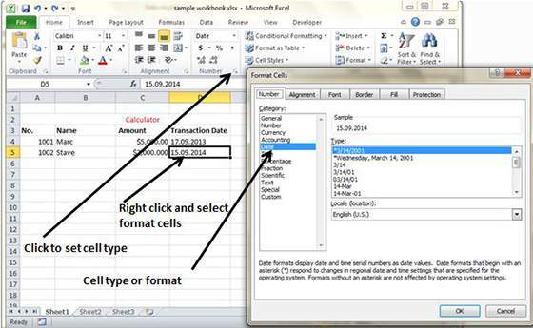

## Various Cell formats

Below are various cell formats.

* **General :** This is default cell format of Cell.
* **Number:** This displays cell as number with separator
* **Currency :** This displays cell as currency i.e with currency sign.
* **Accounting :** Similar to Currency used for accounting purpose.
* **Date :** Various date formats are available under this like 17-09-2013, 17th-Sep-2013, etc
* **Time :** Various Time formats are avilable under this like 1.30PM, 13.30, etc
* **Percentage :** This displays cell as percentage with decimal places like 50.00%
* **Fraction :** This displays cell as fraction like 1/4 ,1/2 etc
* **Scientific :** This displays cell as exponential like 5.6E+01
* **Text :** This displays cell as normal text.
* **Special :** This is special formats of cell like Zip code, Phone Number
* **Custom :** You can use custom format by using this.

# Setting Fonts

You can assign any of the fonts that is installed for your printer to cells in a worksheet.

## Setting font from Home

You can set the font of the selected text from **Home » Font group » select the font**

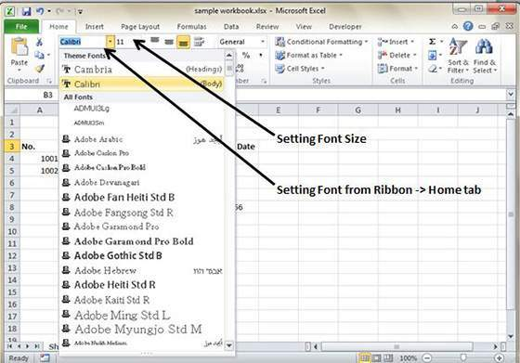

## Setting font from format cell dialogue

* **Right click on cell » Format cells » Font Tab**
* Press **Control + 1** or **Shift + Control + F**

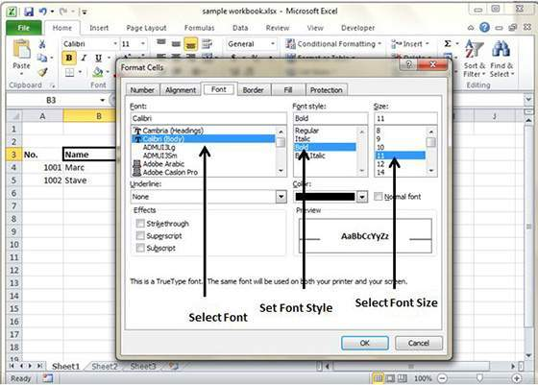

# Text Decoration

You can change the text decoration of the cell to change its look and feel.

## Text-decoration

Various options available in Home tab of the ribbon as below

* **Bold :** It makes text highlighted by choose **Home » Font Group » Click B** or Press **Control + B**
* **Italic :** It makes text italic by choose **Home » Font Group » Click I** or Press **Control + B**
* **Underline :** It makes text to be underlined by choose **Home » Font Group » Click U** or Press **Control + B**
* **Double Underline :** It makes text highlighted by choose **Home » Font Group » Click arrow near U » Select Double Underline**

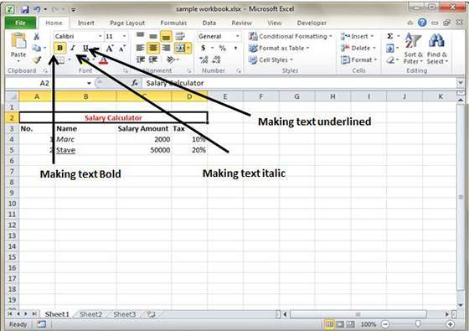

## More text-decoration options

More options available for text decoration in Formatting cells » Font Tab »Effects cells as below

* **Strike-through :** It makes strikes the text in the centre vertically.
* **Super Script :** It makes content to appear as super.
* **Sub Script :** It makes content to appear as sub

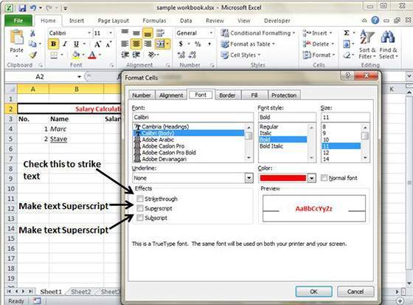

more_text_decoration.jpg

# Rotate Cells

## Rotating Cell From Home Tab

Click on the **orientation** in the **Home tab**. Choose options available like Angle CounterClockwise, Angle Clockwise, etc.

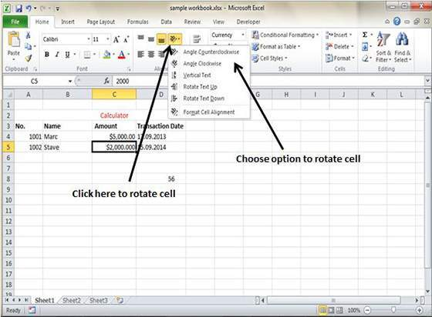

## Rotating Cell from Formatting Cell

Right Click on the cell. Choose **Format cells » Alignment » Set the degree for rotation**

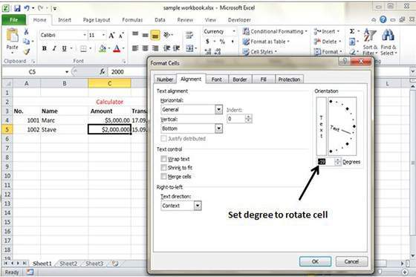

# Setting Colors

You can change the background color of the cell or text color.

## Changing Background Color

By default the background color of the cell is white in MS Excel. You can change it as per your need from **Home tab » Font group » Background color**

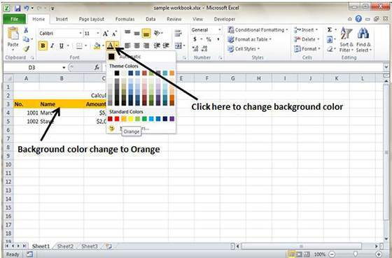

## Changing Foreground Color

By default the foreground or text color is black in MS Excel. You can change it as per your need from **Home tab » Font group » Foreground color**

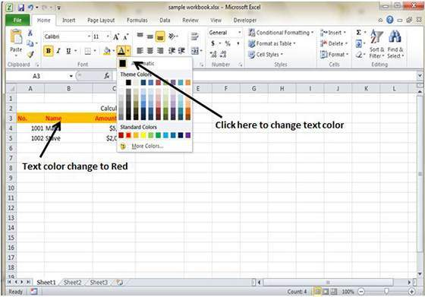

Also you can change foreground color by select cell **Right click » Format cells » Font Tab » Color**

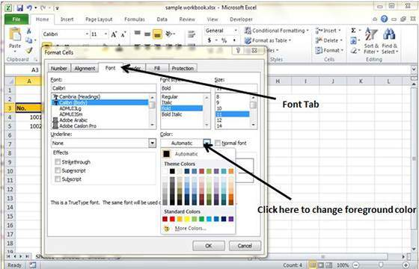

# Text Alignments

If you don’t like the default alignment of cell, you can make changes in the alignment of cell.Below are various ways of doing it.

## Change Alignment from Home Tab

You can change Horizontal and vertical alignment of the cell. By default, Excel aligns numbers to the right and text to the left. Click on the available option in the Alignment group in Home tab to change alignment.

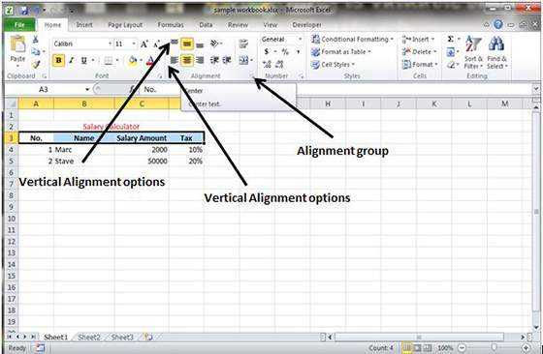

## Change Alignment from Format cells

Right click on cell and choose format cell. In format cells dialogue choose **Alignment Tab.**Select the available options from the Vertical alignment and HOrizontal alignment options

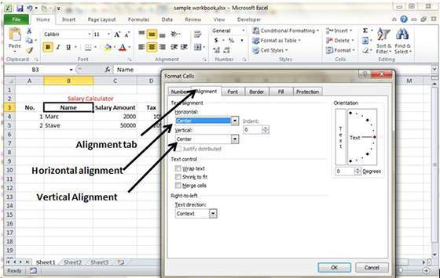

## Exploring Alignment Options

**1. Horizontal Alignment :** You can set horizontal alignment to Left, Centre, Right, etc.

* **Left :** Aligns the cell contents to the left side of the cell.
* **Center:** Centers the cell contents in the cell.
* **Right :** Aligns the cell contents to the right side of the cell.
* **Fill :** Repeats the contents of the cell until the cell’s width is filled.
* **Justify :** Justifies the text to the left and right of the cell. This option is applicable only if the cell is formatted as wrapped text and uses more than one line.

**2. Vertical Alignment :** You can set Vertical alignment to top, Middle, bottom, etc.

* **Top :** Aligns the cell contents to the top of the cell.
* **Center :** Centers the cell contents vertically in the cell.
* **Bottom :** Aligns the cell contents to the bottom of the cell.
* **Justify :** Justifies the text vertically in the cell; this option is applicable only if the cell is formatted as wrapped text and uses more than one line.

# Merge & Wrap

## Merge Cells

MS Excel enables you to merge two or more cells. When you merge cells, you don’t combine the contents of cells. Rather, you combine a group of cells into a single cell that occupies the same space.

You can merge cells by various ways as below

* Choose **Merge & Center control** on the Ribbon is simpler.To merge cells, select the cells that you want to merge and then click the Merge & Center button.

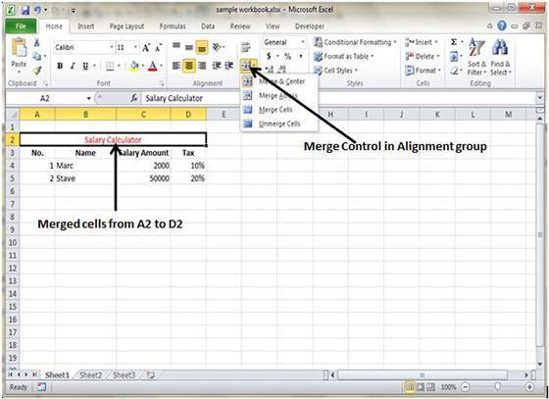

* Choose **Alignment tab** of the Format Cells dialogue box to merge cells

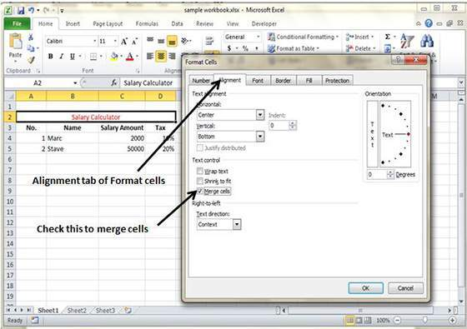

## Additional Options

The **Home » Alignment group » Merge & Center control** contains a drop-down list with these additional options:

* **Merge Across :** When a multi-row range is selected, this command creates multiple merged cells — one for each row.
* **Merge Cells :** Merges the selected cells without applying the Center attribute.
* **Unmerge Cells :** Unmerges the selected cells.

## Wrap Text and Shrink to Fit

If you have text too wide to fit the column width but don’t want that text to spill over into adjacent cells, you can use either the Wrap Text option or the Shrink to Fit option to accommodate that text.

# Borders and Shades

## Apply Borders

MS Excel enables you to apply borders to the cells.For applying border select the range of cells **Right Click » Format cells » Border Tab » Select the Border Style**

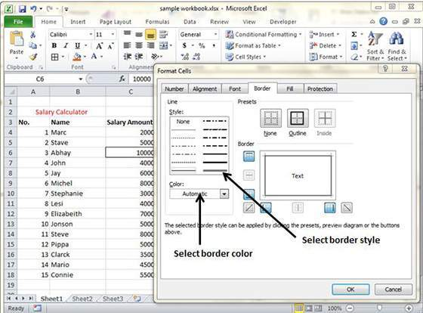

Then you can apply border by **Home Tab » Font group »Apply Borders**

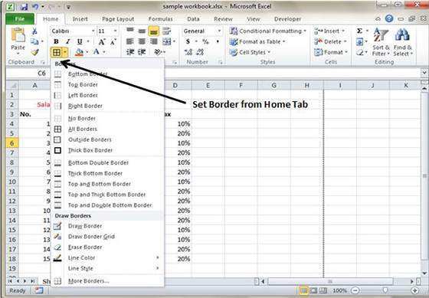

## Apply Shading

You can add shading to the cell from the **Home tab » Font Group » Select the Color**

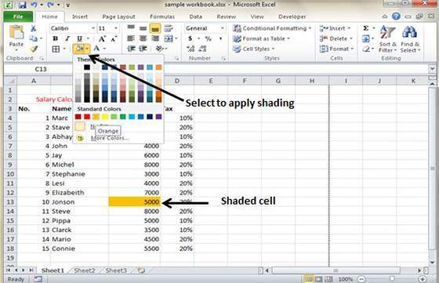

# Apply Formatting

## Formatting Cells

In MS Excel you can apply formatting to the cell or range of cells by **Right Click» Format cells»Select the tab.** Various tabs are available as below

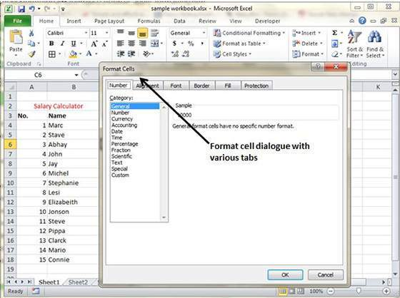

# Sheet Options

## Sheet Options

MS Excel provides various sheet options for printing purpose like generally cell gridlines aren’t printed. If you want your printout to include the gridlines, Choose **Page Layout » Sheet Options group » Gridlines » Check Print**

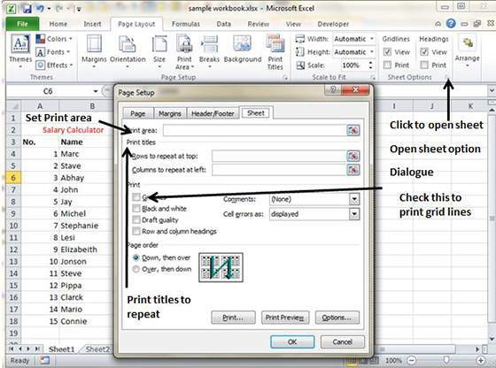

## Options in Sheet options Dialogue

* **Print Area :** You can set print area with this option.
* **Print Titles :** You can set titles to appear at the top for rows and at the left for columns.
* **Print :**
  + **Gridlines :** Gridlines to appear while printing worksheet.
  + **Black & White :** Select this check box to have your color printer print the chart in black and white.
  + **Draft quality :** Select this check box to print the chart using your printer’s draft-quality setting.
  + **Rows & Column Heading :** Select this check box to have rows and column heading to print.
* **Page Order :**
  + **Down, then Over :** It prints the down pages first and then right pages.
  + **Over, then Down :** It prints right pages first and then come to print down pages.

# Adjust Margins

## Margins

Margins are the unprinted areas along the sides, top, and bottom of a printed page. All printed pages in MS Excel have the same margins. You can’t specify different margins for different pages.

You can set margins by various ways as below

* Choose **Page Layout » Page Setup » Margins drop-down list,** you can select **Normal, Wide, Narrow, or the custom Setting.**

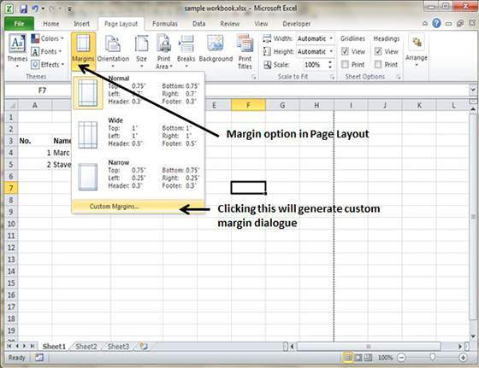

* These options are also available when you choose **File » Print.**

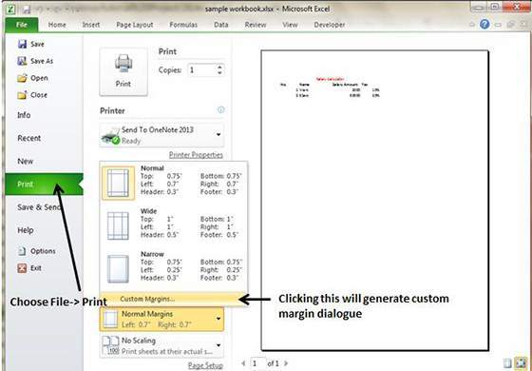

If none of these settings does the job, choose Custom Margins to display the Margins tab of the Page Setup dialog box, as shown below.

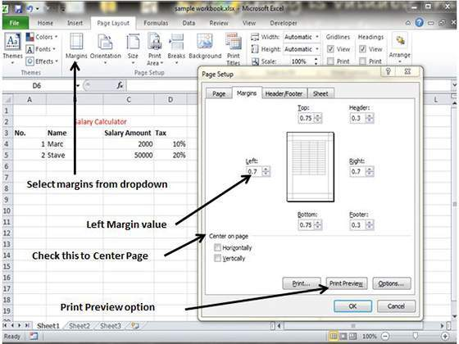

## Center on Page

By default, Excel aligns the printed page at the top and left margins. If you want the output to be centered vertically or horizontally, select the appropriate check box in the Center on Page section of the Margins tab as shown in above screenshot.

# Page Orientation

## Page Orientation

Page orientation refers to how output is printed on the page. If you change the orientation, the onscreen page breaks adjust automatically to accommodate the new paper orientation.

## Types of Page Orientation

* **Portrait :** Portrait to print tall pages (the default).
* **Landscape :** Landscape to print wide pages. Landscape orientation is useful when you have a wide range that doesn’t fit on a vertically oriented page.

## Changing Page Orientation

* Choose **Page Layout » Page Setup » Orientation » Portrait or Landscape**

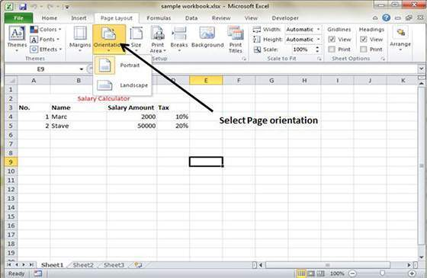

* Choose **File » Print**

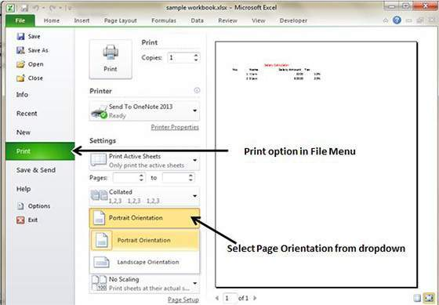

# Header and Footer

## Header and Footer

A header is information that appears at the top of each printed page and a footer is information that appears at the bottom of each printed page. By default, new workbooks do not have headers or footers.

## Adding Header and Footer

* Choose **Page Setup dialog box » Header or Footer tab**

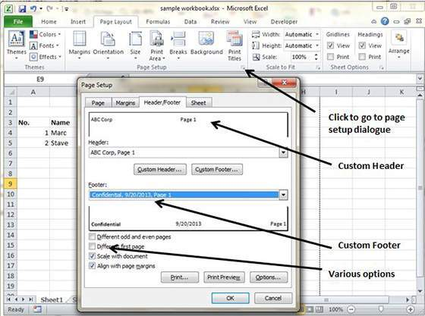

You can choose predefined header and footer or create your custom

* **&[Page] :** Displays the page number
* **&[Pages] :** Displays the total number of pages to be printed
* **&[Date] :** Displays the current date
* **&[Time] :** Displays the current time
* **&[Path]&[File] :** Displays the workbook’s complete path and filename
* **&[File] :** Displays the workbook name
* **&[Tab] :** Displays the sheet’s name

## Other header and footer options

When a header or footer is selected in Page Layout view, the **Header & Footer » Design » Options** group contains controls that let you specify other options:

* **Different First Page :** Check this to specify a different header or footer for the first printed page.
* **Different Odd & Even Pages :** Check this to specify a different header or footer for odd and even pages.
* **Scale with Document :** If checked, the font size in the header and footer will be sized.Accordingly if the document is scaled when printed. This option is enabled, by default.
* **Align with Page Margins :** If checked, the left header and footer will be aligned with the left margin, and the right header and footer will be aligned with the right margin. This option is enabled, by default.

# Insert Page Break

## Page Breaks

If you don’t want a row to print on a page by itself or you don't want a table header row to be the last line on a page. MS Excel gives you precise control over **page breaks.**

MS Excel handles page breaks automatically, but sometimes you may want to force a page break**either a vertical or a horizontal one** so that the report prints the way you want.

For example, if your worksheet consists of several distinct sections, you may want to print each section on a separate sheet of paper.

## Inserting Page Breaks

**Insert Horizontal Page Break:** For example, if you want row 14 to be the first row of a new page, select cell A14. Then choose **Page Layout » Page Setup Group » Breaks» Insert Page Break.**

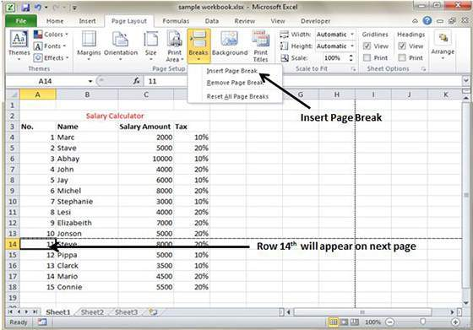

**Insert vertical Page break** In this case make sure to place the pointer in row 1. Choose **Page Layout » Page Setup » Breaks » Insert Page Break** to create the page break.

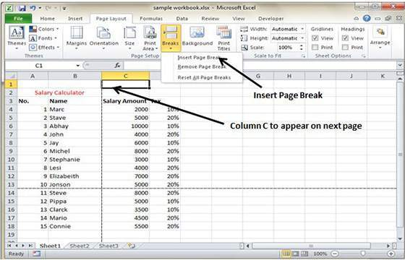

## Removing Page Breaks

* **Remove a page break you’ve added :** Move the cell pointer to the first row beneath of the manual page break and then choose Page Layout » Page Setup » Breaks » Remove Page Break.
* **Remove all manual page breaks :** Choose Page Layout » Page Setup » Breaks » Reset All Page Breaks.

# Set Background

## Background Image

If you like to have a background image on your printouts then Unfortunately, you can’t. You may have noticed the **Page Layout » Page Setup » Background command.** This button displays a dialogue box that lets you select an image to display as a background. Placing this control among the other print-related commands is very misleading. Background images placed on a worksheet are never printed.

## Alternative to placing Background

* You can insert a Shape, WordArt, or a picture on your worksheet and then adjust its transparency. Then copy the image to all printed pages.
* You can insert an object in a page header or footer.

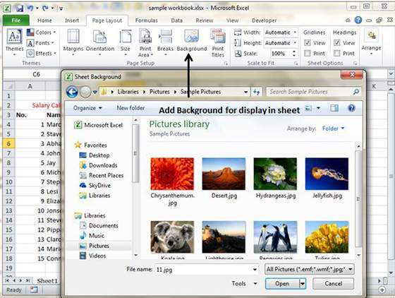

# Freeze Panes

## Freezing Panes

If you set up a worksheet with row or column headings, these headings will not be visible when you scroll down or to the right.MS Excel provides a handy solution to this problem with freezing panes. Freezing panes keeps the headings visible while you’re scrolling through the worksheet.

## Using Freeze Panes

Follow below steps to do freeze panes

* Select the First row or First Column or row Below are which you want to freeze or Column right to area which you want to freeze
* Choose **View Tab » Freeze Panes**
* Select the suitable option
  + **Freeze Panes :** To freeze area of cells
  + **Freeze Top Row :** To freeze first row of worksheet
  + **Freeze First Column :** To freeze first Column of worksheet

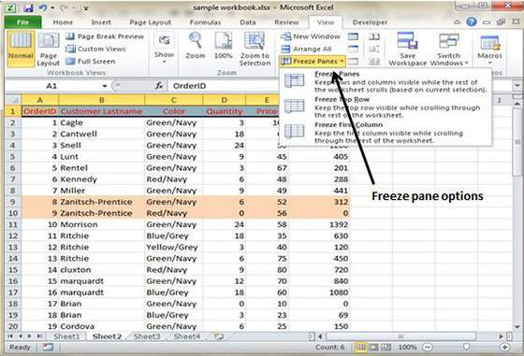

* If you selected Freeze top row you can see first row appears at the top after scrolling also. See below screen-shot

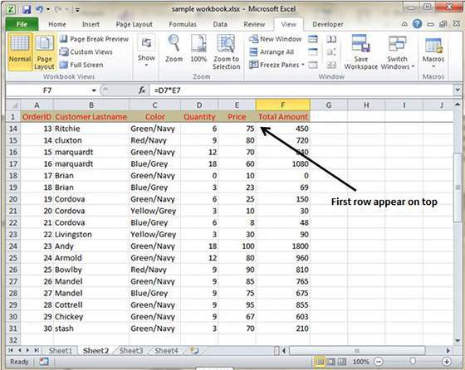

## Unfreeze Panes

To unfreeze Panges choose **View Tab » Unfreeze Panes**

# Conditional Format

## Conditional Formatting

MS Excel 2010 Conditional Formatting feature enables you to format a range of values so that values outside certain limits,are automatically formatted.

Choose **Home Tab » Style group » Conditional Formatting dropdown.**

## Various conditional formatting options

* **Highlight Cells Rules :** It opens a continuation menu with various options for defining formatting rules that highlight the cells in the cell selection that contain certain values, text, or dates, or that have values greater or less than a particular value, or that fall within a certain ranges of values.

Suppose you want to find cell with Amount 0 and Mark them as red.Choose **Range of cell » Home Tab » Conditional Formatting DropDown » Highlight Cell Rules » Equal To**

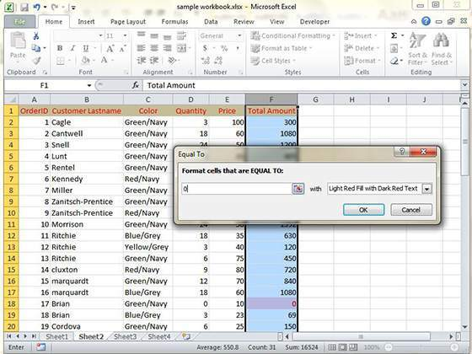

After Clicking ok the cells with value zero are marked as red.

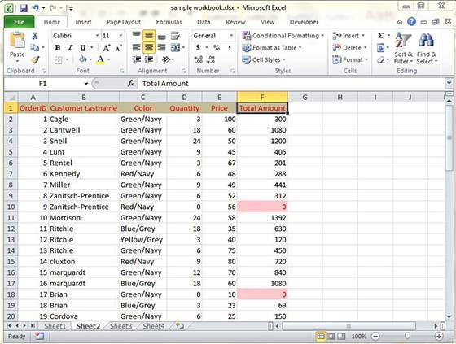

* **Top/Bottom Rules :** It opens a continuation menu with various options for defining formatting rules that highlight the top and bottom values, percentages, and above and below average values in the cell selection.

Suppose you want to highlight top 10% rows you can do this with these Top/Bottom rules

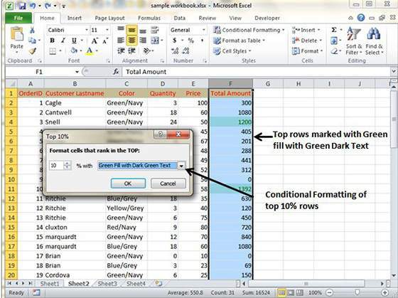

* **Data Bars :** It opens a palette with different color data bars that you can apply to the cell selection to indicate their values relative to each other by clicking the data bar thumbnail.

With this conditional Formatting data Bars will appear in each cell.

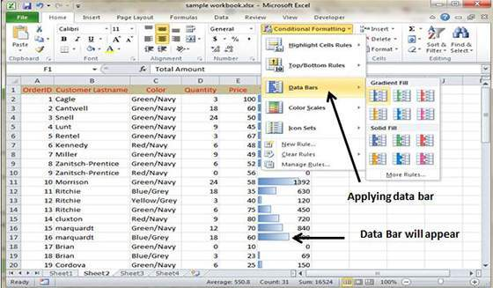

* **Color Scales :** It opens a palette with different three- and two-colored scales that you can apply to the cell selection to indicate their values relative to each other by clicking the color scale thumbnail.

See below screenshot with Color Scales conditional formatting applied.

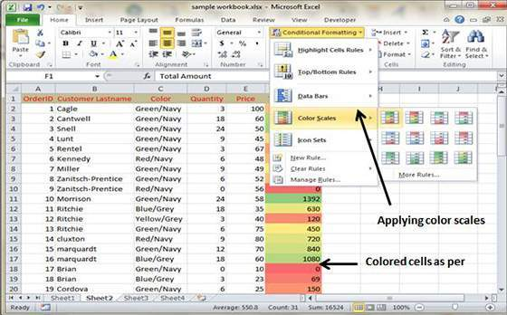

* **Icon Sets :** It opens a palette with different sets of icons that you can apply to the cell selection to indicate their values relative to each other by clicking the icon set.

See below screenshot with Icon Sets conditional formatting applied.

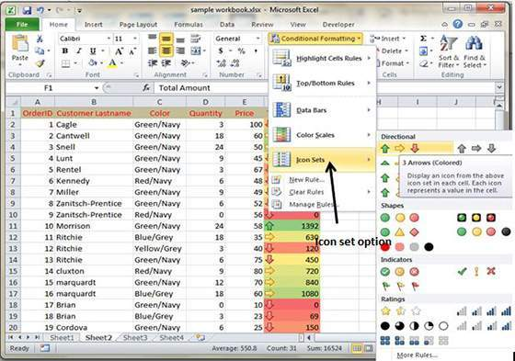

* **New Rule :** It opens the New Formatting Rule dialog box, where you define a custom conditional formatting rule to apply to the cell selection.
* **Clear Rules :** It opens a continuation menu, where you can remove conditional formatting rules for the cell selection by clicking the Selected Cells option, for the entire worksheet by clicking the Entire Sheet option, or for just the current data table by clicking the This Table option.
* **Manage Rules :** It opens the Conditional Formatting Rules Manager dialog box, where you edit and delete particular rules as well as adjust their rule precedence by moving them up or down in the Rules list box.

# Creating Formulas

## Formulas in MS Excel

Formulas are the Bread and butter of worksheet.Without formula worksheet will be just simple tabular representation of data. A formula consists of special code which is entered into a cell. It performs some calculations and returns a result, which is displayed in the cell.

Formulas use a variety of operators and worksheet functions to work with values and text. The values and text used in formulas can be located in other cells, which makes changing data easy and gives worksheets their dynamic nature. For example, you can quickly change the data in a worksheet and formulas works.

## Elements of Formulas

A formula can consist of any of these elements:

* **Mathematical operators, such as +(for addition) and *(for multiplication)**

**Example:**

* + =A1+A2 Adds the values in cells A1 and A2.
* **Values or text**

**Example:**

* + =200*0.5 Multiplies 200 times 0.5. This formula uses only values, and it always returns the same result as 100.
* **Cell references (including named cells and ranges)**

**Example:**

* + =A1=C12 Compares cell A1 with cell C12. If the cells are identical, the formula returns TRUE; otherwise, it returns FALSE.
* **Worksheet functions (such as SUMor AVERAGE)**

**Example:**

* + =SUM(A1:A12) Adds the values in the range A1:A12.

## Creating Formula

For creating formula you need to type in Formula Bar.Formula begins with '=' sign. When building formulas manually, you can either type in the cell addresses or you can point to them in the worksheet. Using the **Pointing method** to supply the cell addresses for formulas is often easier and more powerful method of formula building. When you are using built-in functions, you click the cell or drag through the cell range that you want used when defining the function’s arguments in the Function Arguments dialog box.See below screen shot.

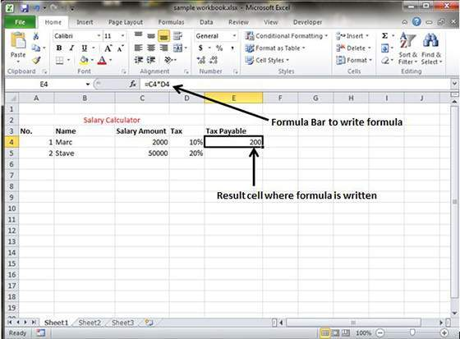

As soon as you complete a formula entry, Excel calculates the result, which is then displayed inside the cell within the worksheet (the contents of the formula, however, continue to be visible on the Formula bar anytime the cell is active). If you make an error in the formula that prevents Excel from being able to calculate the formula at all, Excel displays an Alert dialog box suggesting how to fix the problem.

# Copying Formulas

## Copying Formulas in MS Excel

Copying formulas is one of the most common tasks that you do in a typical spreadsheet that relies primarily on formulas. When a formula uses cell references rather than constant values, Excel makes the task of copying an original formula to every place that requires a similar formula.

## Relative cell addresses

MS Excel does it automatically adjusting the cell references in the original formula to suit the position of the copies that you make. It does this through a system known as **relative cell addresses,** where by the column references in the cell address in the formula change to suit their new column position and the row references change to suit their new row position.

Let us see this with the help of example.Suppose we want sum of all the rows at last then we will write a formula for first column i.e. B. We want sum of the rows from 3 to 8 in the 9th row.

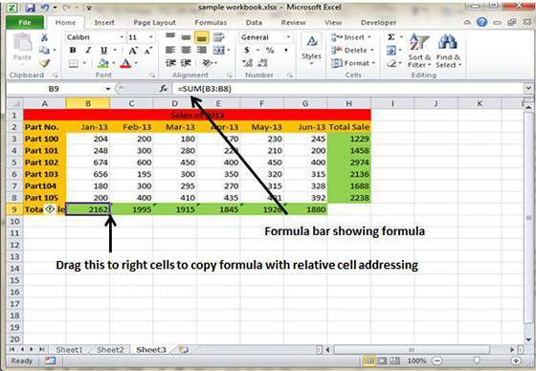

After writing formula in the 9th row, we can drag it to remaining columns and the formula gets copied. After dragging we can see the formula in the remaining columns as below.

* **column C :** =SUM(C3:C8)
* **column D :** =SUM(D3:D8)
* **column E :** =SUM(E3:E8)
* **column F :** =SUM(F3:F8)
* **column G :** =SUM(G3:G8)

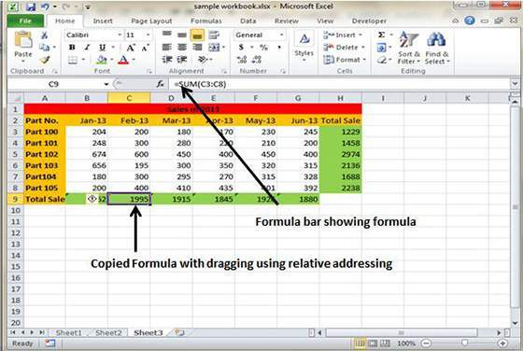

# Formula Reference

## Cell references in Formulas

Most formulas you create include references to cells or ranges. These references enable your formulas to work dynamically with the data contained in those cells or ranges. For example, if your formula refers to cell C2 and you change the value contained in C2, the formula result reflects new value automatically.If you didn’t use references in your formulas, you would need to edit the formulas themselves in order to change the values used in the formulas.

When you use a cell (or range) reference in a formula, you can use three types of references:relative, absolute, and mixed references

## Relative Cell References

The row and column references can change when you copy the formula to another cell because the references are actually offsets from the current row and column. By default, Excel creates relative cell references in formulas.

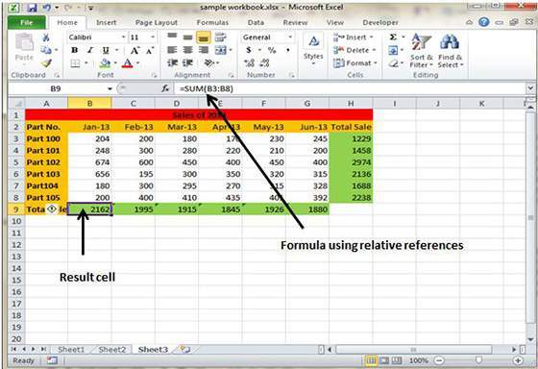

## Absolute Cell References

The row and column references do not change when you copy the formula because the reference is to an actual cell address. An absolute reference uses two dollar signs in its address: one for the column letter and one for the row number (for example, $A$5).

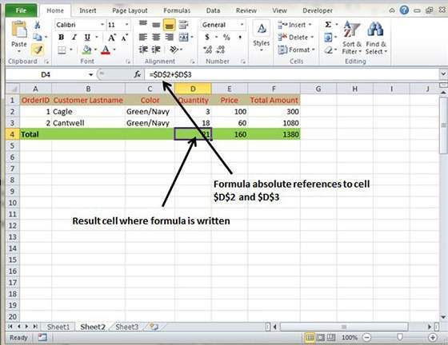

## Mixed Cell References

Either the row or column reference is relative, and the other is absolute. Only one of the address parts is absolute (for example, $A5 or A$5)

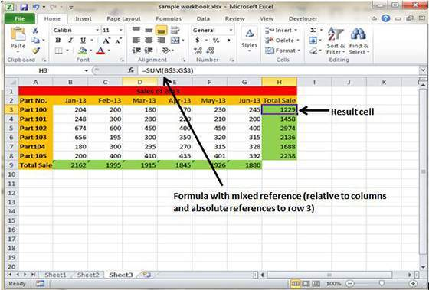

# Using Functions

## Functions in Formula

Many formulas you create use available worksheet functions. These functions enable you to greatly enhance the power of your formulas and perform calculations that are difficult if you use only the operators. For example, you can use the LOG or SIN function to calculate the Logarithm or Sin ratio. You can’t do this complicated calculation by using the mathematical operators alone.

## Using Functions

When you type = sign and then type any alphabet you will see the searched functions as below.

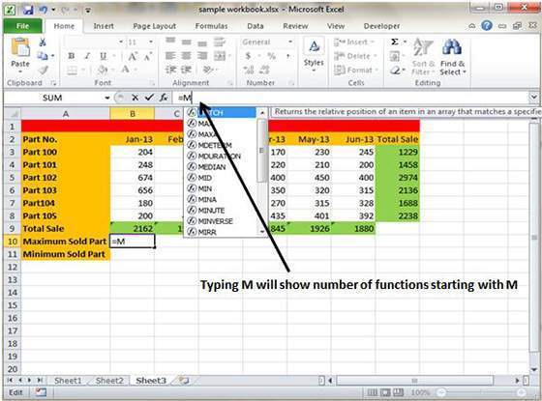

Suppose you need to determine the largest value in a range. A formula can’t tell you the answer without using a function. We will use formula that uses the MAX function to return the largest value in the range B3:B8 as **=MAX(A1:D100)**

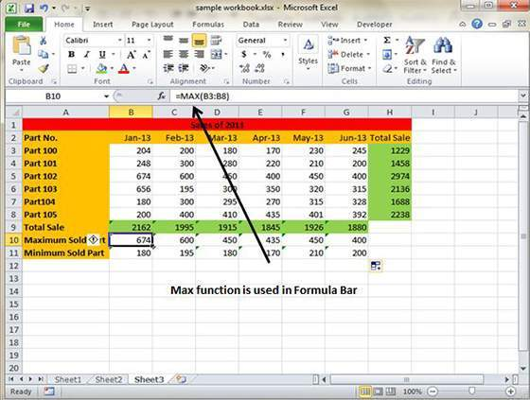

Another example of functions.Suppose you want to find if cell of month is greater than 1900 then we can give Bonus to Sales representative. The we can achieve it with writing formula with IF functions as **=IF(B9>1900,"Yes","No")**

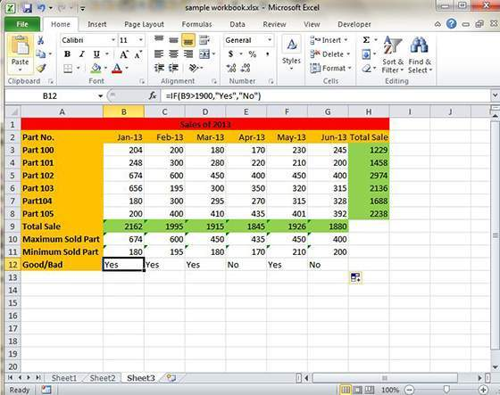

## Function arguments

In the above examples, you may have noticed that all the functions used parentheses. The information inside the parentheses is the list of arguments.

Functions vary in how they use arguments. Depending on what it has to do, a function may use.

* **No arguments :** Examples: Now(),Date(),etc
* **One argument :** UPPER(),LOWER(),etc
* **A fixed number of arguments :** IF(),MAX(),MIN(),AVERGAGE(),etc.
* **Infinite number of arguments:**
* **Optional arguments:**

# Bultin Functions

## Built in Functions

MS Excel has many built in functions which we can use in our formula. To see all the functions by category choose **Formulas Tab » Insert Function.** Then Insert function Dialog appears from which we can choose function.

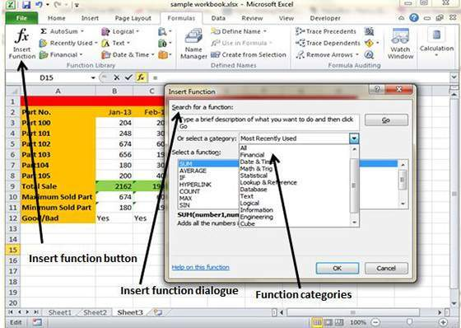

## Functions by categories

Let us see some of the built in functions in MS Excel.

* **Text Functions**
  + **LOWER :** Converts all characters in a supplied text string to lower case
  + **UPPER :** Converts all characters in a supplied text string to upper case
  + **TRIM :** Removes duplicate spaces, and spaces at the start and end of a text string
  + **CONCATENATE :** Joins together two or more text strings
  + **LEFT :** Returns a specified number of characters from the start of a supplied text string
  + **MID :** Returns a specified number of characters from the middle of a supplied text string
  + **RIGHT :** Returns a specified number of characters from the end of a supplied text string
  + **LEN :** Returns the length of a supplied text string.
  + **FIND :** Returns the position of a supplied character or text string from within a supplied text string (case-sensitive)
* **Date & Time**
  + **DATE :** Returns a date, from a user-supplied year, month and day
  + **TIME :** Returns a time, from a user-supplied hour, minute and second
  + **DATEVALUE :** Converts a text string showing a date, to an integer that represents the date in Excel's date-time code
  + **TIMEVALUE :** Converts a text string showing a time, to a decimal that represents the time in Excel
  + **NOW :** Returns the current date & time
  + **TODAY :** Returns today's date
* **Statistical**
  + **MAX :** Returns the largest value from a list of supplied numbers
  + **MIN :** Returns the smallest value from a list of supplied numbers
  + **AVERAGE :** Returns the Average of a list of supplied numbers
  + **COUNT:** Returns the number of numerical values in a supplied set of cells or values
  + **COUNTIF :** Returns the number of cells (of a supplied range), that satisfy a given criteria
  + **SUM :** Returns the sum of a supplied list of numbers
* **Logical**
  + **AND :** Tests a number of user-defined conditions and returns TRUE if ALL of the conditions evaluate to TRUE, or FALSE otherwise
  + **OR :** Tests a number of user-defined conditions and returns TRUE if ANY of the conditions evaluate to TRUE, or FALSE otherwise
  + **NOT** : Returns a logical value that is the opposite of a user supplied logical value or expression i.e. returns FALSE is the supplied argument is TRUE and returns TRUE if the supplied argument is FALSE)
* **Math & Trig**
  + **ABS :** Returns the absolute value (ie. the modulus) of a supplied number
  + **SIGN :** Returns the sign (+1, -1 or 0) of a supplied number
  + **SQRT :** Returns the positive square root of a given number
  + **MOD :** Returns the remainder from a division between two supplied numbers

# Data Filtering

## Filters in MS Excel

Filtering data in MS Excel refers to displaying only the rows that meet certain conditions. (The other rows gets hidden.)

Using the store data, If you are interested in seeing data where Shoe Size is 36. Then You can set filter to do this. Follow below steps to do this

* Place a cursor on the Header Row
* Choose **Data Tab » Filter** to set filter

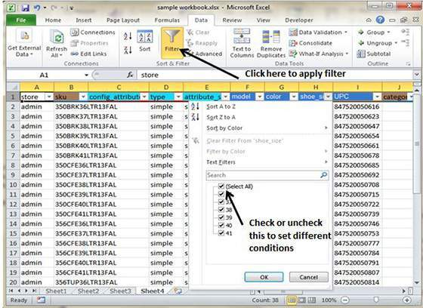

* Click the drop-down arrow in the Area Row Header and remove the check mark from Select All which unselects everything.
* Then select the check mark for Size 36 which will filter the data and displays data of Shoe Size 36
* some of the row numbers are missing; these rows contain the filtered (hidden) data.
* There is drop-down arrow in the Area column now shows a different graphic — an icon that indicates the column is filtered

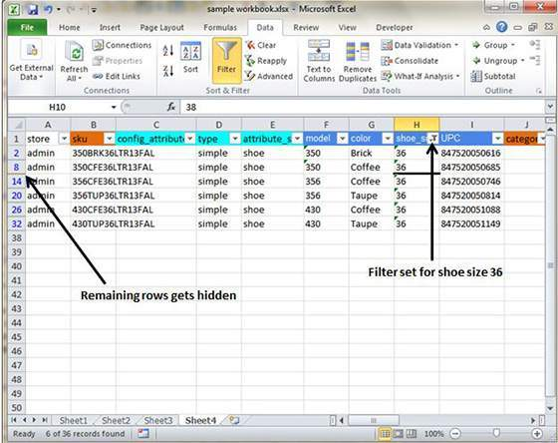

## Using Multiple Filters

You can filter the records by multiple conditions i.e. by multiple column values. Suppose after size 36 is filtered you need to have filter where color is equal to Coffee. After setting filter for Shoe Size, choose Color column and then set filter for color

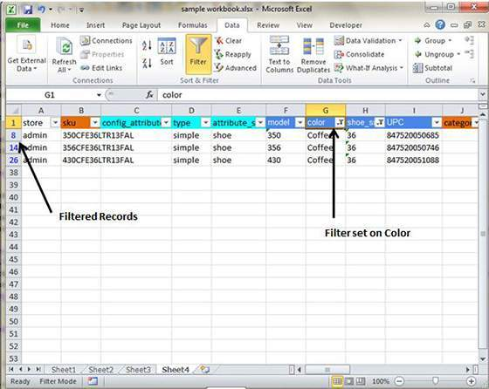

# Data Sorting

## Sorting in MS Excel

Sorting data in MS Excel rearranges the rows based on the contents of a particular column. You may want to sort a table to put names in alphabetical order. Or, maybe you want to sort data by Amount from smallest to largest or largest to smallest.

To Sort the data follow below steps.

* Select the Column by which you want to sort data.
* Choose Data Tab » Sort Below dialog appears

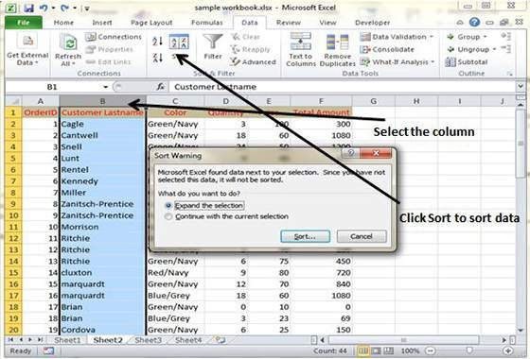

* If you want sort data based on selected column Choose Continue with the selection or If you want sorting based on other columns choose Expand Selection.
* You can Sort based on below Conditions.
  + **Values :** Alphabetically or numerically
  + **Cell Color** : Based on Color of Cell
  + **Font Color** : Based on Font color
  + **Cell Icon** : Based on Cell Icon

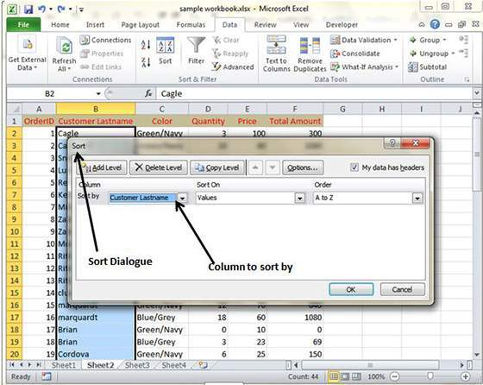

* Clicking Ok will sort the data.

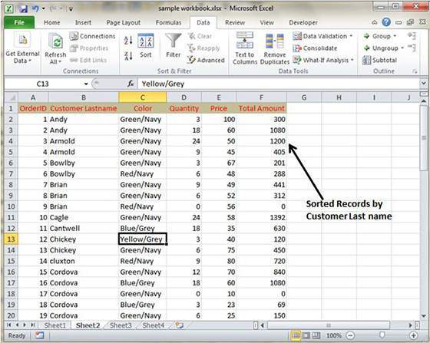

Sorting option is also avilable from the Home Tab. Choose Home Tab » Sort & Filter. You can see same dialog to sort records.

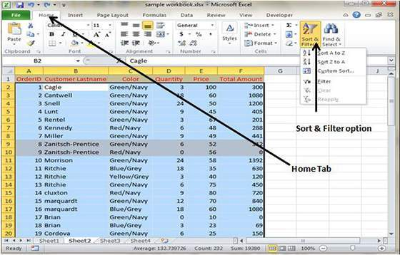

# Using Ranges

## Ranges in MS Excel

A cell is a single element in a worksheet that can hold a value, some text, or a formula. A cell is identified by its address, which consists of its column letter and row number. For example, cell B1 is the cell in the second column and the first row.

A group of cells is called a range. You designate a range address by specifying its upper-left cell address and its lower-right cell address, separated by a colon

Example of Ranges

* **C24** : A range that consists of a single cell
* **A1:B1** : Two cells that occupy one row and two columns
* **A1:A100** : 100 cells in column A
* **A1:D4** : 16 cells (four rows by four columns)

## Selecting Ranges

You can select a range in several ways:

* Press the left mouse button and drag, highlighting the range. Then release the mouse button. If you drag to the end of the screen, the worksheet will scroll.
* Press the Shift key while you use the navigation keys to select a range.
* Press F8 and then move the cell pointer with the navigation keys to highlight the range.Press F8 again to return the navigation keys to normal movement.
* Type the cell or range address into the Name box and press Enter. Excel selects the cell or range that you specified.

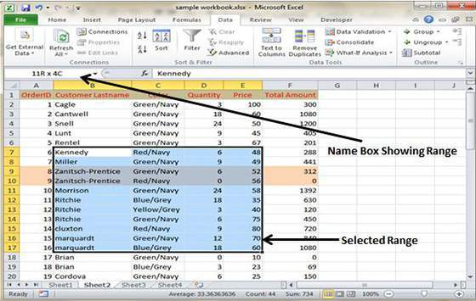

## Selecting complete rows and columns

When you need to select an entire row or column. You can select entire rows and columns in much the same manner as you select ranges:

* Click the row or column border to select a single row or column.
* To select multiple adjacent rows or columns, click a row or column border and drag to highlight additional rows or columns.
* To select multiple (nonadjacent) rows or columns, press Ctrl while you click the row or column borders that you want.

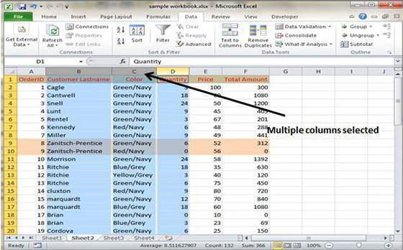

## Data Validation:

MS Excel data validation feature allows you to set up certain rules that dictate what can be entered into a cell. For example, you may want to limit data entry in a particular cell to whole numbers between 0 and 10. If the user makes an invalid entry, you can display a custom message as shown below

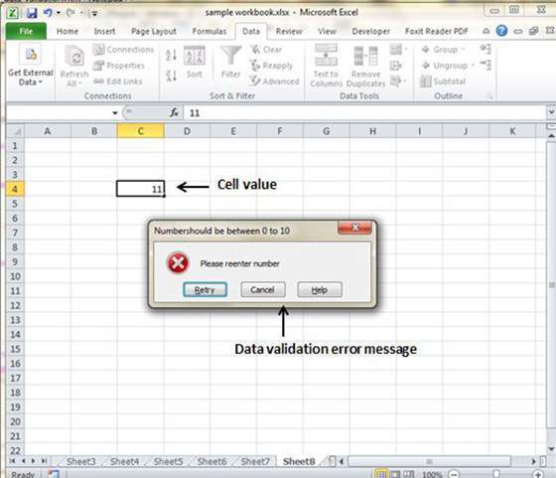

## Validation Criteria

To specify the type of data allowable in a cell or range, follow the steps below while you refer to which shows all three tabs of the Data Validation dialog box.

* Select the cell or range.
* Choose Data » Data Tools » Data Validation. Excel displays its Data Validation dialog box having 3 tabs settings, Input Message and Error alert.

## Settings tab

Here you can set the type of validation you need.Choose an option from the Allow drop-down list.The contents of the Data Validation dialog box will change, displaying controls based on your choice.

* **Any Value :** Selecting this option removes any existing data validation.
* **Whole Number :** The user must enter a whole number.For example, you can specify that the entry must be a whole number greater than or equal to 50.
* **Decimal :** The user must enter a number. For example, you can specify that the entry must be greater than or equal to 10 and less than or equal to 20.
* **List :** The user must choose from a list of entries you provide.You will create drop-down list with this validation. You have to give input ranges then those values will appear in the drop-down.
* **Date :** The user must enter a date. You specify a valid date range from choices in the Data drop-down list. For example, you can specify that the entered data must be greater than or equal to January 1, 2013, and less than or equal to December 31, 2013.
* **Time :** The user must enter a time. You specify a valid time range from choices in the Data drop-down list. For example, you can specify that the entered data must be later than 12:00 p.m.
* **Text Length :** The length of the data (number of characters) is limited. You specify a valid length by using the Data drop-down list. For example, you can specify that the length of the entered data be 1 (a single alphanumeric character).
* **Custom :** To use this option, you must supply a logical formula that determines the validity of the user’s entry (a logical formula returns either TRUE or FALSE).

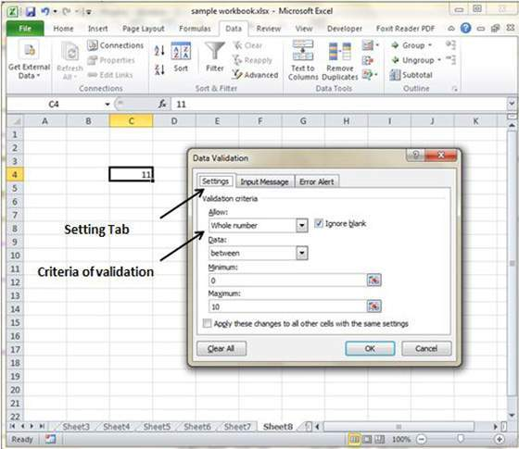

## Input Message tab

You can set the input help message with this tab. Fill the title and Input message of the Input message tab and the input message will appear when cell is selected..

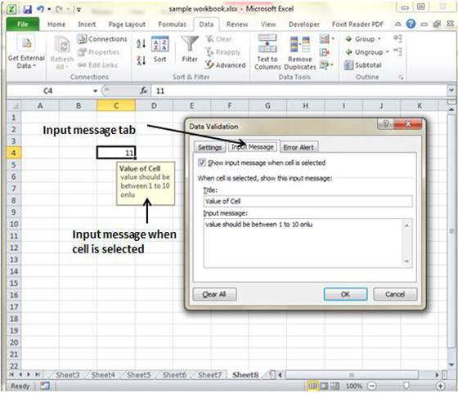

## Error Alert Tab

You can specify error message with this tab. Fill the title and error message. Select the style of the error as stop, warning or Information as per you need.

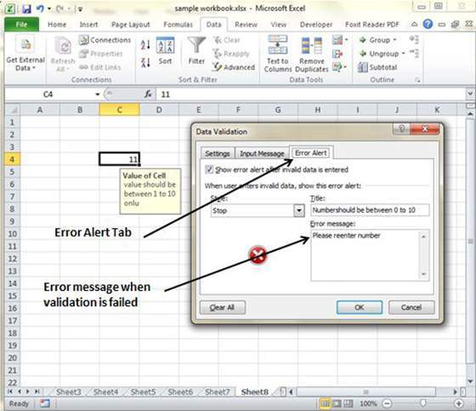

# Using Themes

## Using themes in MS Excel

To help users create more professional-looking documents MS Excel has incorporated a concept known as document themes.Using themes is an easy to specify the colors, fonts, and a variety of graphic effects in a document. And best of all, changing the entire look of your document is a breeze. A few mouse clicks is all it takes to apply a different theme and change the look of your workbook.

## Applying Themes

Choose **Page layout Tab » Themes Dropdown**. Note that this display is a live preview:that is, as you move your mouse over the Theme temporarily displays the theme effect. When you see a style you like, click it to apply the style to the selection.

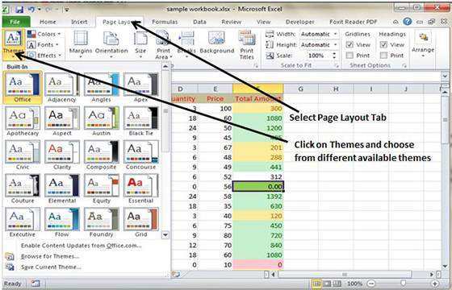

## Creating Custom Theme in MS Excel

We can create new custom Theme in Excel 2010.To create a new style, follow these steps:

* Click on save current theme option under Theme in Page Layout Tab
* This will save the current theme to office folder.
* You can browse the theme later to load the theme.

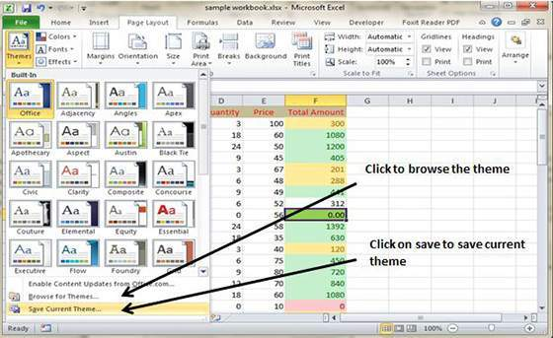

# Using Templates

## Using templates in MS Excel

Template is essentially a model that serves as the basis for something. An Excel template is a workbook that’s used to create other workbooks.

## Viewing Available templates

To view the Excel templates, choose **File » New** to display the available templates screen in Backstage View. You can select a template stored on your hard drive, or a template from Microsoft Office Online. If you choose a template from Microsoft Office Online, you must be connected to the Internet to download it.The Office Online Templates section contains a number of icons, which represent various categories of templates. Click an icon, and you’ll see the available templates.When you select a template thumbnail, you can see a preview in the right panel.

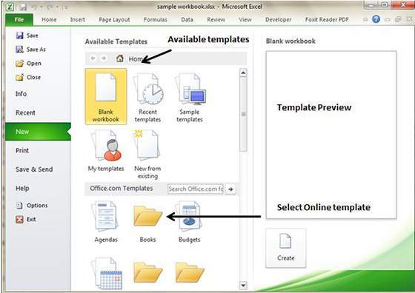

## On-line templates

These template data is available online at the Microsoft server.When you select the template and click on it. It will download the template data from Microsoft server and opens it as shown below.



## Macros in MS Excel

Macros enable you to automate almost any task that you can undertake in Excel 2010. By using macro recorder from **View Tab » Macro Dropdown** to record tasks that you perform routinely, you not only speed up the procedure considerably but you are assured that each step in a task is carried out same way each and every time you perform task.

To view macros choose **View Tab » Macro dropdown**

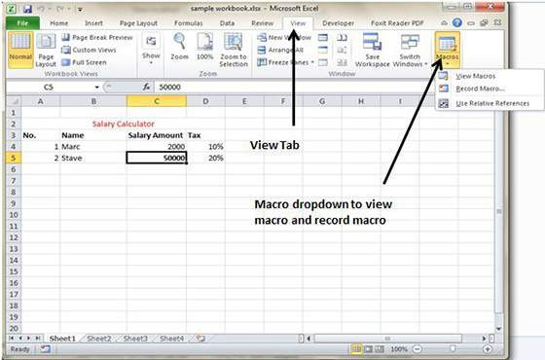

## Macro Options

View tab contains a Macros command button to which a dropdown menu containing the following three options.

* **View Macros :** Opens the Macro dialog box where you can select a macro to run or edit.
* **Record Macro :** Opens the Record Macro dialog box where you define the settings for your new macro and then start the macro recorder; this is the same as clicking the Record Macro button on the Status bar.
* **Use Relative References :** Uses relative cell addresses when recording a macro, making the macro more versatile by enabling you to run it in areas of a worksheet other than the ones originally used in the macro’s recording.

## Creating Macros

You can create macros in one of two ways:

* Use MS Excel’s macro recorder to record your actions as you undertake them in a worksheet
* Enter the instructions that you want followed in VBA code in the Visual Basic Editor

Now lets create a simple simple macro that will automate the task of making cell content Bold and apply cell color.

* Choose View Tab » Macro dropdown
* Click on Record Macro as below

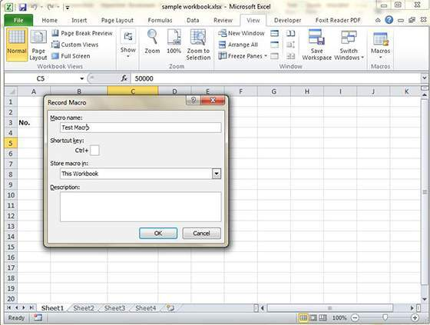

* Now Macro recording will start.
* Do the steps of action which you want to perform repeatedly. Macro will record those steps.
* You can stop the macro recording once done with all steps.

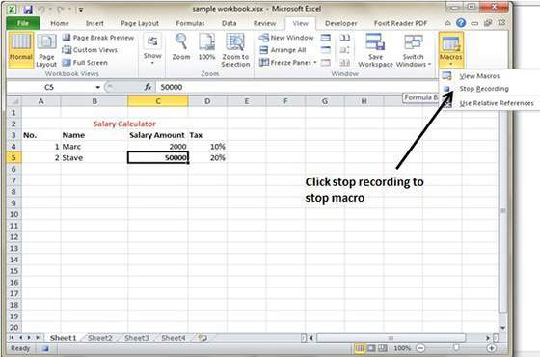

## Edit Macro

You can edit the created Macro at any time. Editing macro will take you to the VBA programming editor

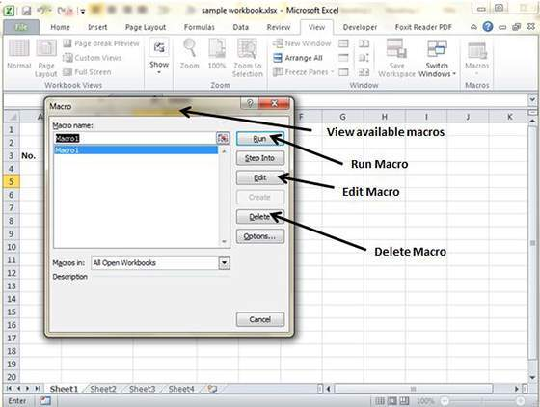

# Adding Graphics

## Graphic Objects in MS Excel

MS Excel supports various types of graphic objects like Shapes gallery, SmartArt, Text Box, and WordArt available on the Insert tab of the Ribbon.Graphics are available in the **Insert Tab.** See below screenshot for vaious avilable grphics in MS Excel 2010.

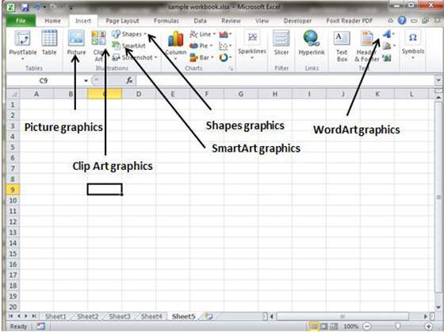

## Insert Shape

* Choose **Insert Tab » Shapes dropdown**
* Select the shape you want to insert. Click on shape to insert it.
* To edit the inserted shape just drag the shape with the mouse. Shape will adjust the shape.

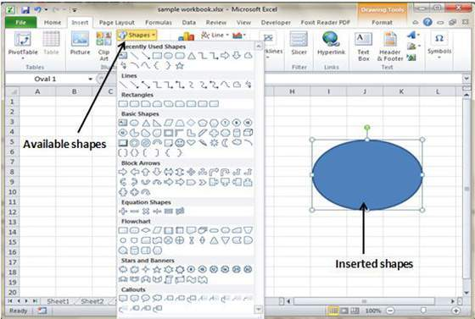

## Insert Smart Art

* Choose **Insert Tab » SmartArt**
* Clicking SmartArt will open the SmartArt dialogue as below screen-shot.Choose from the list of available smartArts
* Click on SmartArt to Insert it in the worksheet
* Edit the SmartArt as per your need

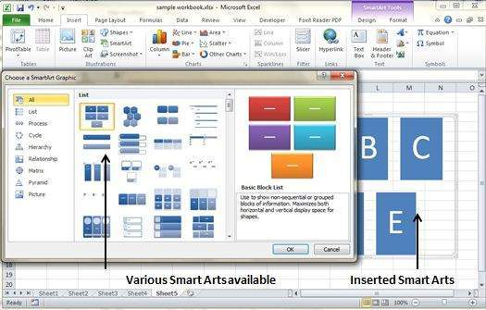

## Insert Clip Art

* Choose **Insert Tab » Clip Art**
* Clicking Clip Art will open the search box as below screen-shot.Choose from the list of available Clip Arts
* Click on Clip Art to Insert it in the worksheet

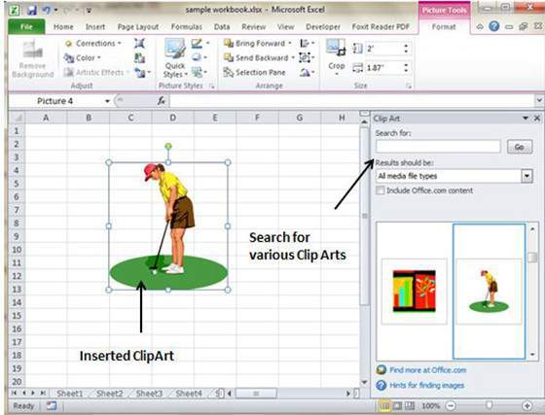

## Insert Word Art

* Choose **Insert Tab » WordArt**
* Select the style of WordArt which you like and click it to enter a text in it.

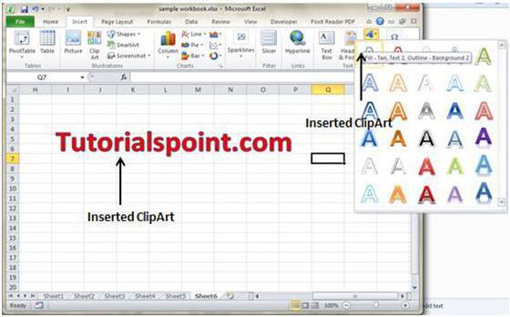

# Cross Referencing

## Graphic Objects in MS Excel

When you have information spread across several different spreadsheets, it can seem a daunting task to bring all these different sets of data together into one meaningful list or table. This is where the Vlookup function comes into its own.

## VLOOKUP

VlookUp searches for a value vertically down for the lookup table. VLOOKUP(lookup_value,table_array,col_index_num,range_lookup) has 4 parameters as below.

* **lookup_value :** It is the user input. This is the value that the function uses to search on.
* **The table_array :** It is the area of cells in which the table is located. This includes not only the column being searched on, but the data columns for which you are going to get the values that you need.
* **Col_index_num :** It is the column of data that contains the answer that you want.
* **Range_lookup** : It is a TRUE or FALSE value. When set to TRUE, the lookup function gives the closest match to the lookup_value without going over the lookup_value. When set to FALSE, an exact match must be found to the lookup_value or the function will return #N/A. Note, this requires that the column containing the lookup_value be formatted in ascending order.

## VLOOKUP Example

Let's look at a very simple example of cross-referencing two spreadsheets. Each spreadsheet contains information about the same group of people. The first spreadsheet has their dates of birth, and the second shows their favourite color. How do we build a list showing the person's name, their date of birth and their favourite color. VLOOOKUP will help in this case. Firstly let us see data in both the sheets.

This is data in the first sheet

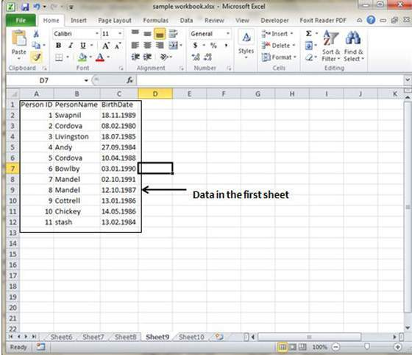

This is data in the first sheet

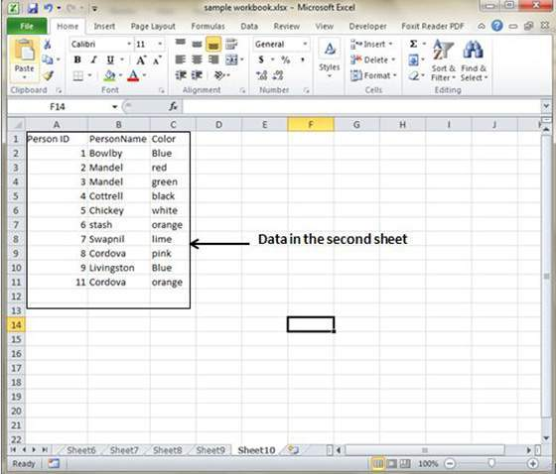

Npw for finding the respective favourite color for that person from another sheet we need to vlookup the data.First argument to the VLOOKUP is lookup value (In this case it is person name). Second argument is table array which is table in the second sheet from B2 to C11. Third argument to VLOOKUP is Column index num which is answer which we are looking for. In this case it is 2 the color column number is 2. The fourth argument is True returning partial match or false returning exact match.After applying VLOOKUP formula it will calculate the color and results are displayed as below.

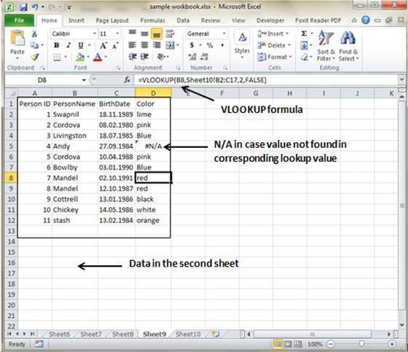

As you can see in the above screen-shot that results of VLOOKUP has searched for color in second sheet table. It has returned #N/A in case where match is not found. In this case Andy's data is not present in the second sheet so it returned #N/A.

# Printing Worksheets

## Quick Print

If you want to print a copy of a worksheet with no layout adjustment, use the Quick Print option. There are two ways in which we can use this option.

* Choose **File » Print**(which displays the Print pane), and then click the Print button.
* Press Ctrl+P and then click the Print button (or press Enter).

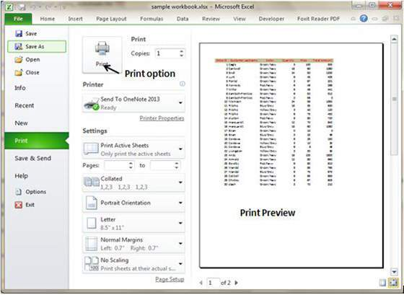

## Adjusting Common Page Setup Settings

You can adjust print settings available in Page setup dialogue in different ways as below.Page setup options include Page orientation, Page Size, Page Margins, etc.

* The Print screen in Backstage View, displayed when you choose **File » Print**
* The **Page Layout tab** of the Ribbon

## Choosing your printer

To switch to a different printer, choose **File » Print** and use the drop-down control in the Printer section to select a different installed printer.

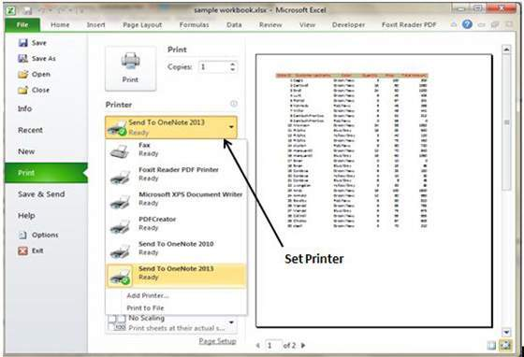

## Specifying what you want to print

Sometimes you may want to print only a part of the worksheet rather than the entire active area. Choose **File » Print** and use the controls in the Settings section to specify what to print.

* **Active Sheets :** Prints the active sheet or sheets that you selected
* **Entire Workbook :** Prints the entire workbook, including chart sheets
* **Selection :** Prints only the range that you selected before choosing **File » Print**

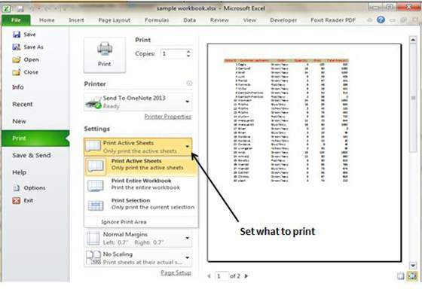

# Email Workbooks

## Email Workbook

MS Excel allows you to email the workbook very easily. To email the workbook to anyone follow below steps.

* Choose **File » Save and Send.** It basically saves the document first and then emails.

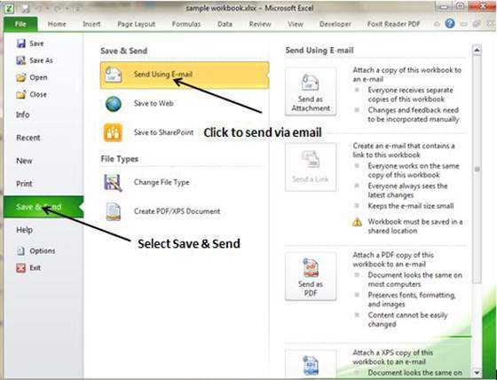

* Click on Send using E-mail.If your email system is configured. MS Outlook will open with the file as attachment in the New Email Window.You can send mail to anyone this workbook with valid email address.

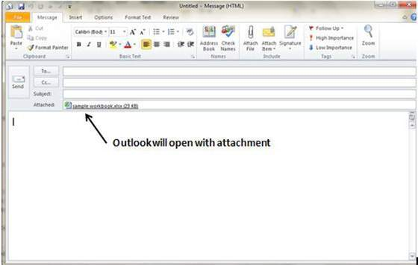

## Translate Worksheet

You can translate text written in a different language, such as phrases or paragraphs, individual words (by using the Mini Translator), or translate your whole file with MS Excel 2010.

Translation is available in review tab of ribbon in MS Excel 2010. You can quickly translate cell into different language with this option.

## Performing translation step by step

* select the content which you want to translate to different language.
* Choose **review tab » translation.**
* It will open the pane from which you can select the language to which you need to translate.
* You need to have internet connection for performing translation. It will translate using Microsoft Translator.
* Click on Insert to apply translation changes.

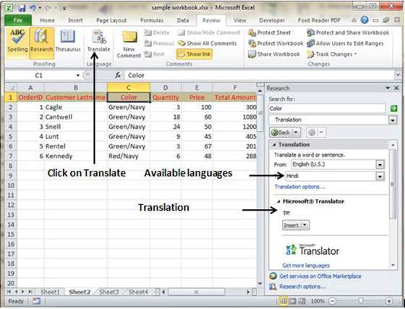

# Workbook Security

## Workbook Security

We can apply security to the workbook by the concept of protection available in the Review Tab of ribbon. MS Excel's protection-related features fall into three categories.

* **Worksheet protection :** Protecting a worksheet from being modified, or restricting the modifications to certain users.
* **Workbook protection :** Protecting a workbook from having sheets inserted or deleted, and also requiring the use of password to open the workbook

## Protect Worksheet

You may want to protect a worksheet for a variety of reasons. One reason is to prevent yourself or others from accidentally deleting formulas or other critical data. A common scenario is to protect a worksheet so that the data can be changed, but the formulas can’t be changed.

To protect a worksheet, choose **Review » Changes group »Protect Sheet.** Excel displays the Protect Sheet dialog box. Note that providing a password is optional. If you enter a password, that password will be required to unprotect the worksheet. You can selected various option in which the sheet should be protected.Suppose we checked Format Cells option then Excel will not allow to format cells.

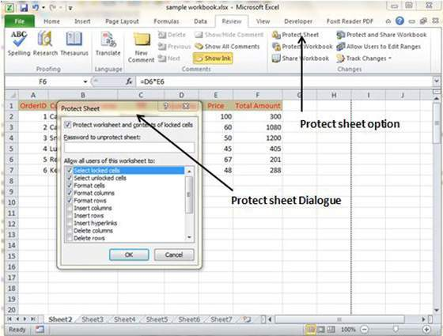

When somebody tries format the cells he or she will get the error as below.

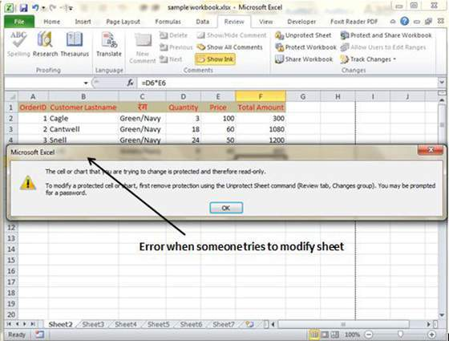

To unprotect a protected sheet, choose Review » Changes group » Unprotect Sheet. If the sheet was protected with a password, you’re prompted to enter that password.

## Protecting a Workbook

Excel provides three ways to protect a workbook.

* Require a password to open the workbook.
* Prevent users from adding sheets, deleting sheets, hiding sheets, and unhiding sheets.
* Prevent users from changing the size or position of windows.

## Requiring a password to open a workbook

Excel lets you save a workbook with a password. After doing so, whoever tries to open the workbook must enter the password.To add a password to a workbook, follow these steps.

* Choose File » Info » Protect Workbook » Encrypt With Password.Excel displays the Encrypt Document dialog box.
* Type a password and click OK.
* Type the password again and click OK.
* Save the workbook.

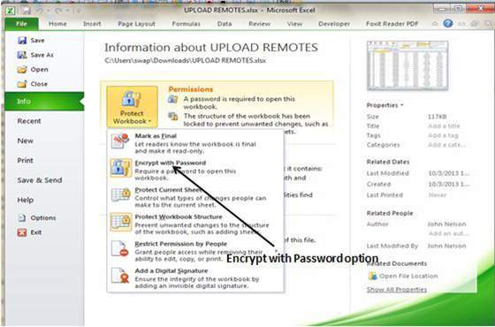

To remove a password from a workbook, repeat the same procedure. In Step 2, however, delete the existing password symbols.

## Protecting workbook’s structure and Windows

To prevent others (or yourself) from performing certain actions in a workbook, you can protect the workbook’s structure and windows. When a workbook’s structure and windows is protected, the user may not Add a sheet, Delete a sheet, Hide a sheet, unhide a sheet,etc and may not allowed to change size or position of a workbook’s windows respectively.

To protect a worksheet’s structure and windows follow below steps

* Choose **Review » Changes group » Protect Workbook** to display the Protect Workbook dialog box.
* In the Protect Workbook dialog box, select the Structure check box and Windows check box.
* (Optional) Enter a password.
* Click OK.

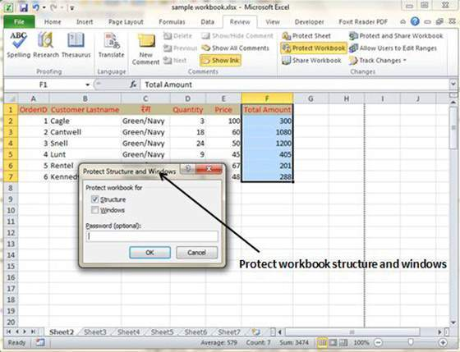

# Data Tables

## Data Tables

In Excel, a Data Table is a way to see different results by altering an input cell in your formula. Data tables are available in **Data Tab » What-If analysis dropdown » Data table** in MS Excel



## Data Table with Example

Now let us see data table concept with an example. Suppose you have Price and quantity many values. Also you have discount for that as third variable for calculating Net Price. You can keep the Net Price value in the organized table format with the help of data table.Your Price runs horizontally to right while quantity runs vertically down. We are using formula to calculate Net Price as Price multiplied by Quantity minus total discount (Quantity * Discount for each quantity)

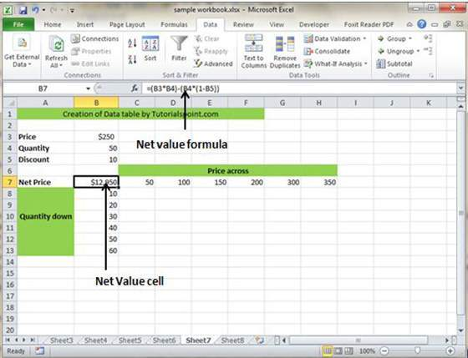

Now for creation of data table select the range of data table. Choose **Data Tab » What-If analysis dropdown » Data table.** It will give you dialogue asking for Input row and Input Column. Give the Input row as Price cell(In this case cell B3) and Input column as quantity cell(In this case cell B4). Please see below screen-shot.

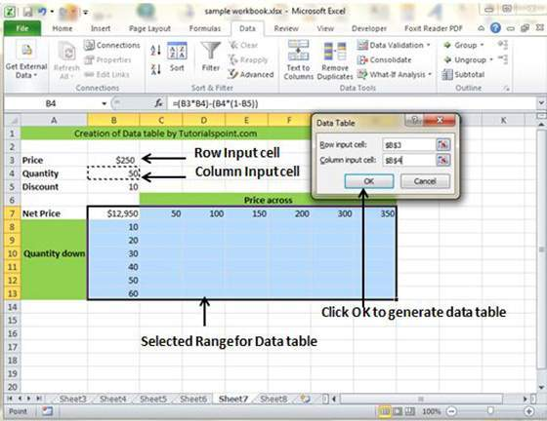

Clicking OK will generate data table as shown in below screen-shot. It will generate the table formula. You can change the price horizontally or quantity vertically to see changed in the Net Price.

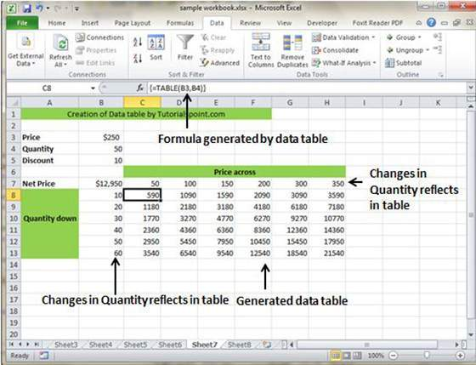

# Pivot Tables

## Pivot tables

A pivot table is essentially a dynamic summary report generated from a database. The database can reside in a worksheet (in the form of a table) or in an external data file. A pivot table can help transform endless rows and columns of numbers into a meaningful presentation of the data. Pivot table are very powerful tool for summarized analysis of the data.

Pivot tables are available under **Insert tab » PivotTable dropdown » PivotTable**

## Pivot Table Example

Now let us see Pivot table with the help of example.Suppose you have huge data of voters and you want to see summarized data of voter Information per party then you can use Pivot table for it. Choose **Insert tab » Pivot Table** to insert pivot table. MS Excel selects the data of the table.You can select the pivot table location as existing sheet or new sheet.

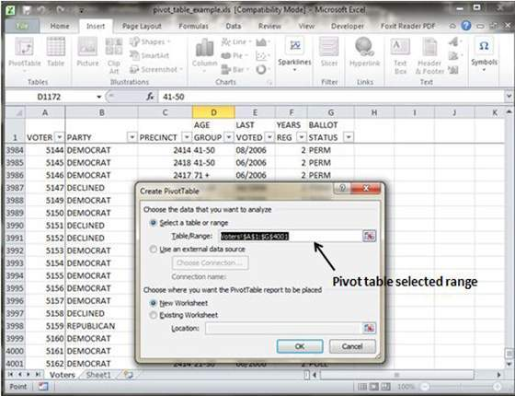

This will generate the Pivot table pane as shown below.You have various options available in Pivot table pane as below. You can select fields for the generated pivot table.

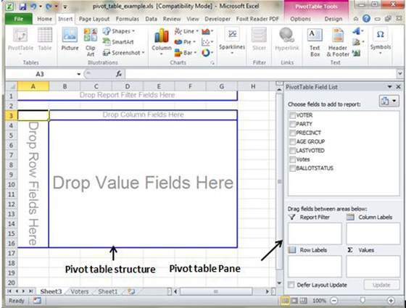

* **Column labels :** A field that has a column orientation in the pivot table. Each item in the field occupies a column.
* **Report Filter :** You can set the filter for the report as year then data gets filtered as per the year.
* **Row labels:** A field that has a row orientation in the pivot table. Each item in the field occupies a row.
* **Values area :** The cells in a pivot table that contain the summary data. Excel offers several ways to summarize the data (sum, average, count, and so on).

After giving input fields to the pivot table, It will generate the pivot table with the data as below.

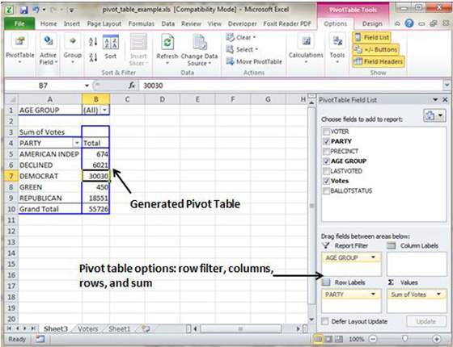

# Simple Charts

## Charts

A chart is a visual representation of numeric values. Charts (also known as graphs) have been an integral part of spreadsheets.Charts generated by early spreadsheet products were quite crude, but thy have improved significantly over the years. Excel provides you with the tools to create a wide variety of highly customizable charts.Displaying data in a well-conceived chart can make your numbers more understandable. Because a chart presents a picture, charts are particularly useful for summarizing a series of numbers and their interrelationships.

## Types of Charts

There are various chart types available in MS Excel as shown in below screen-shot.

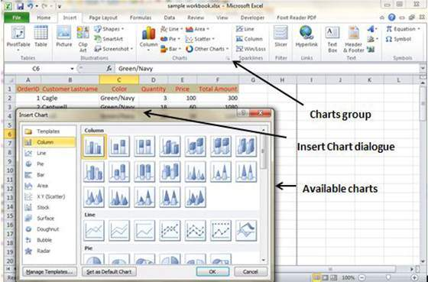

* **Column** : Column chart shows data changes over a period of time or illustrates comparisons among items.
* **Bar** : A bar chart illustrates comparisons among individual items.
* **Pie**: A pie chart shows the size of items that make up a data series, proportional to the sum of the items. It always shows only one data series and is useful when you want to emphasize a significant element in the data.
* **Line** : A line chart shows trends in data at equal intervals.
* **Area :** An area chart emphasizes the magnitude of change over time.
* **X Y Scatter** : An xy (scatter) chart shows the relationships among the numeric values in several data series, or plots two groups of numbers as one series of xy coordinates.
* **Stock :** This chart type is most often used for stock price data, but can also be used for scientific data (for example, to indicate temperature changes).
* **Surface :** A surface chart is useful when you want to find optimum combinations between two sets of data. As in a topographic map, colors and patterns indicate areas that are in the same range of values.
* **Doughnut :** Like a pie chart, a doughnut chart shows the relationship of parts to a whole; however, it can contain more than one data series.
* **Bubble :** Data that is arranged in columns on a worksheet so that x values are listed in the first column and corresponding y values and bubble size values are listed in adjacent columns, can be plotted in a bubble chart.
* **Radar :** A radar chart compares the aggregate values of a number of data series.

## Creating chart

To create charts for the data by below steps.

* Select the data for which you want to create chart.
* Choose **Insert Tab » Select the chart or click on the Chart group** to see various chart types.
* Select the chart of your choice and click OK to generate the chart.

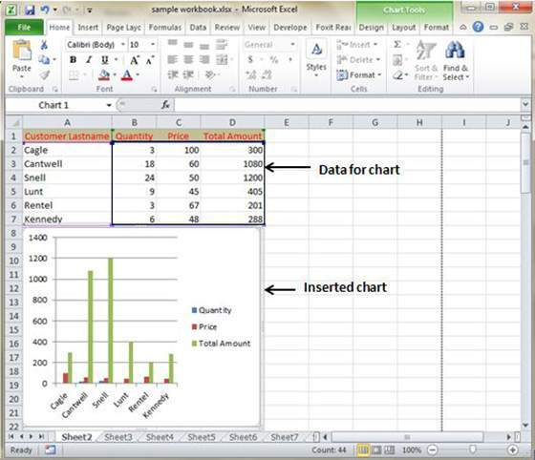

## Editing Chart

You can edit the chart at any time after you have created it.

* You can select the different data for chart input with **Right click on chart » Select data.** Selecting new data will generate the chart as per new data as shown in the below screen-shot.

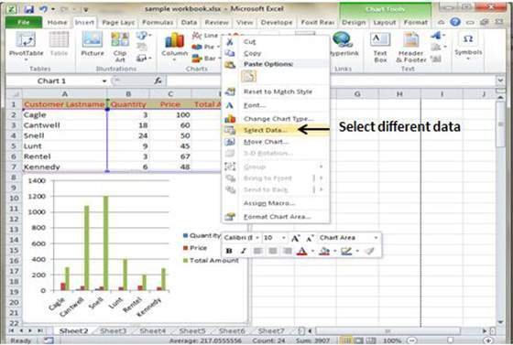

* You can change the X axis of the chart by giving different input to X-axis of chart.
* You can change the Y axis of chart by giving different input to Y-axis of chart.

# Pivot Charts

## Pivot Charts

A pivot chart is a graphical representation of a data summary displayed in a pivot table. A pivot chart is always based on a pivot table. Although Excel lets you create a pivot table and a pivot chart at the same time, you can’t create a pivot chart without a pivot table. All Excel charting features are available in a pivot chart

Pivot charts are available under **Insert tab » PivotTable dropdown » PivotChart**

## Pivot Chart Example

Now let us see Pivot table with the help of example. Suppose you have huge data of voters and you want to see summarized view of the data of voter Information per party in the form of charts then you can use Pivot chart for it. Choose **Insert tab » Pivot Chart** to insert pivot table.

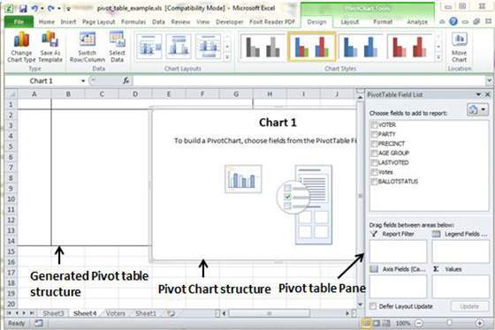

MS Excel selects the data of the table.You can select the pivot chart location as existing sheet or new sheet. Pivot chart will depends on automatically created pivot table by the MS Excel. You can the the generated pivot chart in the below screen-shot

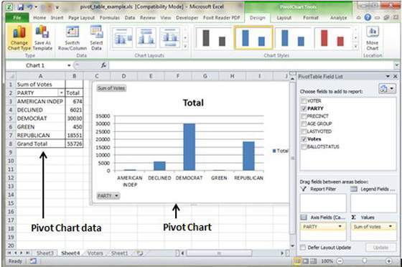

# Keyboard Shortcuts

## MS Excel Keyboard short-cuts

Ms Excel offers many keyboard short-cuts. If you are familiar with windows operating system you are knowing most of them.Below is the list of all the major shortcut keys in Microsoft Excel.

* **Ctrl + A** : Select all contents of the worksheet.
* **Ctrl + B** : Bold highlighted selection.
* **Ctrl + I** : Italic highlighted selection.
* **Ctrl + K** : Insert link.
* **Ctrl + U** : Underline highlighted selection.
* **Ctrl + 1** : Change the format of selected cells.
* **Ctrl + 5** : Strikethrough highlighted selection.
* **Ctrl + P** : Bring up the print dialog box to begin printing.
* **Ctrl + Z** : Undo last action.
* **Ctrl + F3** : Open Excel Name Manager.
* **Ctrl + F9**: Minimize current window.
* **Ctrl + F10** : Maximize currently selected window.
* **Ctrl + F6** : Switch between open workbooks or windows.
* **Ctrl + Page up** : Move between Excel work sheets in the same Excel document.
* **Ctrl + Page down** : Move between Excel work sheets in the same Excel document.
* **Ctrl + Tab** : Move between Two or more open Excel files.
* **Alt + =** : Create a formula to sum all of the above cells
* **Ctrl + '** : Insert the value of the above cell into cell currently selected.
* **Ctrl + Shift + !** : Format number in comma format.
* **Ctrl + Shift + $** : Format number in currency format.
* **Ctrl + Shift + #** : Format number in date format.
* **Ctrl + Shift + %** : Format number in percentage format.
* **Ctrl + Shift + ^** : Format number in scientific format.
* **Ctrl + Shift + @** : Format number in time format.
* **Ctrl + Arrow key** : Move to next section of text.
* **Ctrl + Space** : Select entire column.
* **Shift + Space** : Select entire row.
* **Ctrl + -** : Delete the slected column or row.
* **Ctrl + Shift + =** : Insert a new column or row.
* **Ctrl + Home** : Move to cell A1.
* **Ctrl + ~** : Switch between showing Excel formulas or their values in cells.
* **F2** : Edit the selected cell.
* **F3** : After a name has been created F3 will paste names.
* **F4** : Repeat last action. For example, if you changed the color of text in another cell pressing F4 will change the text in cell to the same color.
* **F5** : Go to a specific cell. For example, C6.
* **F7** : Spell check selected text or document.
* **F11** : Create chart from selected data.
* **Ctrl + Shift + ;** : Enter the current time.
* **Ctrl + ;** : Enter the current date.
* **Alt + Shift + F1** : Insert New Worksheet.
* **Alt + Enter** : While typing text in a cell pressing Alt + Enter will move to the next line allowing for multiple lines of text in one cell.
* **Shift + F3** : Open the Excel formula window.
* **Shift + F5** : Bring up search box.